Nursing Math
Practice Questions,
Answers, and
Techniques

Table of Contents
Table of Contents 2
Questions 3
Metric Conversions (ProCalc type 1) 3
Metric/Household Conversions (ProCalc type 3) 6
Metric/Apothecary Conversions (ProCalc type 4) 9
Oral Meds (ProCalc type 5) 11
Oral Weight Based (ProCalc type 6) 17
Body Surface Area (BSA) (ProCalc type 7) 20
IV mL per hour (ProCalc type 12) 24
Drops per min (Procalc type 13) 31
IV drug dose based on weight (ProCalc type 15) 35
IV mL per hour/min prescribed (Procalc type 16) 38
IV mL per hour based on weight (ProCalc type17) 42
IV how much drug infusing (Procalc type 18) 46
IV titrations (critical care) (ProCalc type 20) 50
Answer Keys 59
Metric Conversions (ProCalc type 1) 59
Metric/Household Conversions (ProCalc type 3) 60
Metric/Apothecary Conversions (ProCalc type 4) 61
Oral Meds (ProCalc type 4) 62
Oral Weight Based (ProCalc type 6) 64
Body Surface Area (BSA) (ProCalc type 7) 65
IV mL per hour (ProCalc type 12) 66
Drops per min (Procalc type 13) 68
IV drug dose based on weight (ProCalc type 15) 69
IV mL per hour/min prescribed (Procalc type 16) 70
IV mL per hour based on weight (ProCalc type17) 71
IV how much drug infusing (Procalc type 18) 72
IV titrations (critical care) (ProCalc type 20) 73
How to Solve 75

Questions

Metric Conversions (ProCalc type 1)
1. 0.8 grams of Trilisate (choline magnesium trisalicylate) must be prepared. Trilisate is available in mg. How many mg of Trilisate should be prepared?
2. 0.2 mg of hydroxocobalamin must be prepared. Hydroxocobalamin is available in mcg. How many mcg of hydroxocobalamin should be prepared?
3. 1,500 mcg of betamethasone must be prepared. Betamethasone is available in mg. How many mg of betamethasone should be prepared?
4. 0.25 mg of Tikosyn (dofetilide) must be prepared. Tikosyn is available in mcg. How many mcg of Tikosyn should be prepared?
5. Prostaphlin (oxacillin) is available in mg. 0.75 grams of Prostaphlin must be prepared. How many mg of Prostaphlin should be prepared?
6. 0.15 mg of digoxin must be prepared. Digoxin is available in mcg. How many mcg of digoxin should be prepared?
7. 500 mcg of Kytril (granisetron) must be prepared. Kytril is available in mg. How many mg of Kytril should be prepared?
8. 1,250 mcg of Versed (midazolam) must be prepared. Versed is available in mg. How many mg of Versed should be prepared?
9. 0.5 grams of Trilisate (choline magnesium trisalicylate) must be prepared. Trilisate is available in mg. How many mg of Trilisate should be prepared?
10. DDAVP (desmopressin acetate) is available in mg. 600 mcg of DDAVP must be prepared. How many mg of DDAVP should be prepared?
11. 1.8 grams of Donnagel (attapulgite) must be prepared. Donnagel is available in mg. How many mg of Donnagel should be prepared?
12. Dilantin-125 (phenytoin) is available in mg. 0.15 grams of Dilantin-125 must be prepared. How many mg of Dilantin-125 should be prepared?
13. Erythromycin estolate is available in mg. 0.125 grams of erythromycin estolate must be prepared. How many mg of erythromycin estolate should be prepared?
14. Digoxin is available in mg. 70 mcg of digoxin must be prepared. How many mg of digoxin should be prepared?
15. Pipracil (piperacillin sodium) is available in grams. 2,000 mg of Pipracil must be prepared. How many grams of Pipracil should be prepared?
16. Daranide (dichlorphenamide) is available in mg. 0.2 grams of Daranide must be prepared. How many mg of Daranide should be prepared?
17. 0.25 grams of cephalothin must be prepared. Cephalothin is available in mg. How many mg of cephalothin should be prepared?
18. Magnesium sulfate is available in mg. 4 grams of magnesium sulfate must be prepared. How many mg of magnesium sulfate should be prepared?
19. 0.1 mg of cyanocobalamin must be prepared. Cyanocobalamin is available in mcg. How many mcg of cyanocobalamin should be prepared?
20. 150 mcg of Catapres (clonidine) must be prepared. Catapres is available in mg. How many mg of Catapres should be prepared?
21. An IV solution contains 2 grams of Bretylol (bretylium tosylate). 2 grams of Bretylol is equivalent to how many mg?
22. Premarin (estrogens, conjugated) is available in mg. 900 mcg of Premarin must be prepared. How many mg of Premarin should be prepared?
23. 200 mcg of digoxin must be prepared. Digoxin is available in mg. How many mg of digoxin should be prepared?
24. 1,200 mcg of colchicine must be prepared. Colchicine is available in mg. How many mg of colchicine should be prepared?
25. 0.6 grams of Neurontin (gabapetin) must be prepared. Neurontin is available in mg. How many mg of Neurontin should be prepared?
26. Isoniazid is available in mg. 400 mcg of isoniazid must be prepared. How many mg of isoniazid should be prepared?
27. Ascorbic acid is available in mg. 3 grams of ascorbic acid must be prepared. How many mg of ascorbic acid should be prepared?
28. Unipen (nafcillin) is available in mg. 0.375 grams of Unipen must be prepared. How many mg of Unipen should be prepared?
29. 0.175 grams of neomycin must be prepared. Neomycin is available in mg. How many mg of neomycin should be prepared?
30. 1.5 grams of Mefoxin (cefoxitin) must be prepared. Mefoxin is available in mg. How many mg of Mefoxin should be prepared?
31. 2.5 grams of Welchol (colesevelam) must be prepared. Welchol is available in mg. How many mg of Welchol should be prepared?
32. 0.3 grams of Anturane (sulfinpyrazone) must be prepared. Anturane is available in mg. How many mg of Anturane should be prepared?
33. Cefonicid is available in mg. 1 gram of cefonicid must be prepared. How many mg of cefonicid should be prepared?
34. Estinyl (ethinyl estradiol) is available in mg. 20 mcg of Estinyl must be prepared. How many mg of Estinyl should be prepared?
35. Permax (pergolide mesylate) is available in mg. 1,000 mcg of Permax must be prepared. How many mg of Permax should be prepared?
36. 250 mcg of hyoscyamine sulfate must be prepared. Hyoscyamine sulfate is available in mg. How many mg of hyoscyamine sulfate should be prepared?
37. Tonocard (tocainide hydrochloride) is available in mg. 0.4 grams of Tonocard must be prepared. How many mg of Tonocard should be prepared?
38. 0.1 gram of Ultram (tramadol hydrochloride) must be prepared. Ultram is available in mg. How many mg of Ultram should be prepared?
39. 25 mcg of levothyroxine sodium must be prepared. Levothyroxine sodium is available in mg. How many mg of levothyroxine sodium should be prepared?
40. Estinyl (ethinyl estradiol) is available in mg. 2,000 mcg of Estinyl must be prepared. How many mg of Estinyl should be prepared?

Metric/Household Conversions (ProCalc type 3)
1. 3 mg of liquid Chlor-Trimeton (chlorpheniramine) has been prescribed. 3 mg is contained in 7.5 mL. A measuring device marked in teaspoons is being used. 7.5 mL is equivalent to how many teaspoons?
2. 75 mg of liquid Furoxone (furazolidone) has been prescribed. 75 mg is contained in 22.5 mL. A measuring device marked in teaspoons is being used. 22.5 mL is equivalent to how many teaspoons?
3. 12.5 mg of liquid fromethazine has been prescribed. 12.5 mg is contained in 2.5 mL. A measuring device marked in teaspoons is being used. 2.5 mL is equivalent to how many teaspoons?
4. 60 mg of liquid Mestinon (pyridostigmine) has been prescribed. 60 mg is contained in 5 mL. A measuring device marked in teaspoons is being used. 5 mL is equivalent to how many teaspoons?
5. 125 mg of liquid Ceftin (cefuroxime) has been prescribed. 125 mg is contained in 5 mL. A measuring device marked in teaspoons is being used. 5 mL is equivalent to how many teaspoons?
6. 250,000 units of liquid Nilstat (nystatin) has been prescribed. 250,000 units is contained in 2.5 mL. A measuring device marked in teaspoons is being used. 2.5 mL is equivalent to how many teaspoons?
7. 210 mg of liquid aminophylline has been prescribed. 210 mg is contained in 10 mL. A measuring device marked in teaspoons is being used. 10 mL is equivalent to how many teaspoons?
8. 375 mg of liquid dicloxacillin has been prescribed. 375 mg is contained in 30 mL. A measuring device marked in tablespoons is being used. 30 mL is equivalent to how many tablespoons?
9. 100 mg of liquid Moban Concentrate (molindone) has been prescribed. 100 mg is contained in 5 mL. A measuring device marked in teaspoons is being used. 5 mL is equivalent to how many teaspoons?
10. 8 mg of liquid Proventil (albuterol) has been prescribed. 8 mg is contained in 20 mL. A measuring device marked in teaspoons is being used. 20 mL is equivalent to how many teaspoons?
11. 200 mg of liquid doxycycline has been prescribed. 200 mg is contained in 20 mL. A measuring device marked in teaspoons is being used. 20 mL is equivalent to how many teaspoons?
12. 25 mg of liquid Vistaril (hydroxyzine) has been prescribed. 25 mg is contained in 5 mL. A measuring device marked in teaspoons is being used. 5 mL is equivalent to how many teaspoons?
13. 4 1/2 teaspoons of cough medicine has been prescribed. A measuring device marked in mL is being used. How many mL should be administered?
14. 300 mg of liquid ferrous fumarate has been prescribed. 300 mg is contained in 15 mL. A measuring device marked in tablespoons is being used. 15 mL is equivalent to how many tablespoons?
15. 3 1/2 teaspoons of cough medicine has been prescribed. A measuring device marked in mL is being used. How many mL should be administered?
16. 5 mg of liquid dexamethasone has been prescribed. 5 mg is contained in 5 mL. A measuring device marked in teaspoons is being used. 5 mL is equivalent to how many teaspoons?
17. 120 mg of liquid acetaminophen has been prescribed. 120 mg is contained in 5 mL. A measuring device marked in teaspoons is being used. 5 mL is equivalent to how many teaspoons?
18. 0.2 mg of liquid dihydrotachysterol has been prescribed. 0.2 mg is contained in 5 mL. A measuring device marked in teaspoons is being used. 5 mL is equivalent to how many teaspoons?
19. 0.625 mg of liquid Levsin (hyoscyamine) has been prescribed. 0.625 mg is contained in 25 mL. A measuring device marked in teaspoons is being used. 25 mL is equivalent to how many teaspoons?
20. 750 mg of liquid Gantanol (sulfamethoxazole) has been prescribed. 750 mg is contained in 7.5 mL. A measuring device marked in teaspoons is being used. 7.5 mL is equivalent to how many teaspoons?
21. 30 mg of liquid prednisone has been prescribed. 30 mg is contained in 30 mL. A measuring device marked in teaspoons is being used. 30 mL is equivalent to how many teaspoons?
22. 1 mg of liquid dexamethasone has been prescribed. 1 mg is contained in 10 mL. A measuring device marked in teaspoons is being used. 10 mL is equivalent to how many teaspoons?
23. 225 mg of liquid Cleocin Pediatric (clindamycin) has been prescribed. 225 mg is contained in 15 mL. A measuring device marked in teaspoons is being used. 15 mL is equivalent to how many teaspoons?
24. 1,000 mg of liquid amoxicillin has been prescribed. 1,000 mg is contained in 20 mL. A measuring device marked in teaspoons is being used. 20 mL is equivalent to how many teaspoons?
25. 500 mg of liquid ampicillin has been prescribed. 500 mg is contained in 5 mL. A measuring device marked in teaspoons is being used. 5 mL is equivalent to how many teaspoons?
26. 250 mg of liquid griseofulvin has been prescribed. 250 mg is contained in 10 mL. A measuring device marked in teaspoons is being used. 10 mL is equivalent to how many teaspoons?
27. 5 grams of liquid Amicar (aminocaproic acid) has been prescribed. 5 grams is contained in 20 mL. A measuring device marked in teaspoons is being used. 20 mL is equivalent to how many teaspoons?
28. 0.8 mg of liquid dihydrotachysterol has been prescribed. 0.8 mg is contained in 20 mL. A measuring device marked in teaspoons is being used. 20 mL is equivalent to how many teaspoons?
29. 1,200 mg of liquid Kaopectate (attapulgite) has been prescribed. 1,200 mg is contained in 30 mL. A measuring device marked in tablespoons is being used. 30 mL is equivalent to how many tablespoons?
30. 400 mg of liquid Vantin (cefpodoxime) has been prescribed. 400 mg is contained in 20 mL. A measuring device marked in teaspoons is being used. 20 mL is equivalent to how many teaspoons?
31. 150 mg of liquid chlorpromazine has been prescribed. 150 mg is contained in 5 mL. A measuring device marked in teaspoons is being used. 5 mL is equivalent to how many teaspoons?
32. 15 mg of liquid methadone has been prescribed. 15 mg is contained in 7.5 mL. A measuring device marked in teaspoons is being used. 7.5 mL is equivalent to how many teaspoons?
33. 4 teaspoons of cough medicine has been prescribed. A measuring device marked in mL is being used. How many mL should be administered?
34. 40 mg of liquid Prozac (fluoxetine) has been prescribed. 40 mg is contained in 10 mL. A measuring device marked in teaspoons is being used. 10 mL is equivalent to how many teaspoons?
35. 325 mg of liquid acetaminophen has been prescribed. 325 mg is contained in 5 mL. A measuring device marked in teaspoons is being used. 5 mL is equivalent to how many teaspoons?
36. 2.5 mg of liquid Prolixin (fluphenazine) has been prescribed. 2.5 mg is contained in 5 mL. A measuring device marked in teaspoons is being used. 5 mL is equivalent to how many teaspoons?
37. 1,250 mg of liquid Gantanol (sulfamethoxazole) has been prescribed. 1,250 mg is contained in 12.5 mL. A measuring device marked in teaspoons is being used. 12.5 mL is equivalent to how many teaspoons?
38. 50 mg of liquid doxycycline has been prescribed. 50 mg is contained in 10 mL. A measuring device marked in teaspoons is being used. 10 mL is equivalent to how many teaspoons?
39. 5 1/2 teaspoons of cough medicine has been prescribed. A measuring device marked in mL is being used. How many mL should be administered?
40. 10 mg of liquid leucovorin has been prescribed. 10 mg is contained in 10 mL. A measuring device marked in teaspoons is being used. 10 mL is equivalent to how many teaspoons?

Metric/Apothecary Conversions (ProCalc type 4)
1. A child weighs 29 lbs, 12 oz. You determine that 29 lbs, 12 oz is equivalent to ___ kg.
2. An adult weighs 153 lbs. You determine that 153 lbs is equivalent to ___ kg.
3. An infant weighs 15 lbs, 12 oz. You determine that 15 lbs, 12 oz is equivalent to ___ kg.
4. An infant weighs 14 lbs, 14 oz. You determine that 14 lbs, 14 oz is equivalent to ___ kg.
5. An infant weighs 19 lbs, 6 oz. You determine that 19 lbs, 6 oz is equivalent to ___ kg.
6. An infant weighs 4800 grams. You determine that 4800 grams is equivalent to ___ kg.
7. An adult weighs 111 lbs. You determine that 111 lbs is equivalent to ___ kg.
8. An infant weighs 11 lbs, 13 oz. You determine that 11 lbs, 13 oz is equivalent to ___ kg.
9. An infant weighs 12 lbs. You determine that 12 lbs is equivalent to ___ kg.
10. A child weighs 56 lbs. You determine that 56 lbs is equivalent to ___ kg.
11. An adult weighs 181 lbs. You determine that 181 lbs is equivalent to ___ kg.
12. A child weighs 23 lbs. You determine that 23 lbs is equivalent to ___ kg.
13. An infant weighs 4900 grams. You determine that 4900 grams is equivalent to ___ kg.
14. An adult weighs 113 lbs. You determine that 113 lbs is equivalent to ___ kg.
15. An infant weighs 13 lbs, 2 oz. You determine that 13 lbs, 2 oz is equivalent to ___ kg.
16. A child weighs 27 lbs, 14 oz. You determine that 27 lbs, 14 oz is equivalent to ___ kg.
17. A child weighs 36 lbs. You determine that 36 lbs is equivalent to ___ kg.
18. An infant weighs 17 lbs, 11 oz. You determine that 17 lbs, 11 oz is equivalent to ___ kg.
19. An infant weighs 11 lbs, 2 oz. You determine that 11 lbs, 2 oz is equivalent to ___ kg.
20. An infant weighs 17 lbs, 3 oz. You determine that 17 lbs, 3 oz is equivalent to ___ kg.
21. An infant weighs 18 lbs, 10 oz. You determine that 18 lbs, 10 oz is equivalent to ___ kg.
22. An infant weighs 20 lbs, 2 oz. You determine that 20 lbs, 2 oz is equivalent to ___ kg.
23. An infant weighs 12 lbs, 10 oz. You determine that 12 lbs, 10 oz is equivalent to ___ kg.
24. A child weighs 26 lbs, 10 oz. You determine that 26 lbs, 10 oz is equivalent to ___ kg.
25. An infant weighs 13 lbs, 11 oz. You determine that 13 lbs, 11 oz is equivalent to ___ kg.
26. An infant weighs 4000 grams. You determine that 4000 grams is equivalent to ___ kg.
27. A child weighs 45 lbs. You determine that 45 lbs is equivalent to ___ kg.
28. A child weighs 21 lbs, 7 oz. You determine that 21 lbs, 7 oz is equivalent to ___ kg.
29. An infant weighs 14 lbs, 9 oz. You determine that 14 lbs, 9 oz is equivalent to ___ kg.
30. An adult weighs 193 lbs. You determine that 193 lbs is equivalent to ___ kg.
31. An infant weighs 15 lbs, 13 oz. You determine that 15 lbs, 13 oz is equivalent to ___ kg.
32. An adult weighs 131 lbs. You determine that 131 lbs is equivalent to ___ kg.
33. An infant weighs 19 lbs, 8 oz. You determine that 19 lbs, 8 oz is equivalent to ___ kg.
34. An adult weighs 128 lbs. You determine that 128 lbs is equivalent to ___ kg.
35. An adult weighs 178 lbs. You determine that 178 lbs is equivalent to ___ kg.
36. A child weighs 29 lbs, 7 oz. You determine that 29 lbs, 7 oz is equivalent to ___ kg.
37. An infant weighs 3800 grams. You determine that 3800 grams is equivalent to ___ kg.
38. A child weighs 43 lbs. You determine that 43 lbs is equivalent to ___ kg.
39. A child weighs 27 lbs, 15 oz. You determine that 27 lbs, 15 oz is equivalent to ___ kg.
40. A child weighs 26 lbs, 3 oz. You determine that 26 lbs, 3 oz is equivalent to ___ kg.

Oral Meds (ProCalc type 5)
1. Pyrazinamide is available in 500 mg scored tablets. 1,250 mg has been prescribed by mouth. You should administer ___ tablets.
2. 0.3 grams of cloxacillin has been prescribed by mouth. The cloxacillin is available in liquid form labeled 125 mg in 5 mL. You should administer ____ mL of the cloxacillin.
3. Cylert (pemoline) is available in 75 mg scored tablets. 112.5 mg has been prescribed by mouth. You should administer ___ tablets.
4. 10 mg tablets of pravastatin sodium are available. How many tablets should be administered if 20 mg of pravastatin sodium is prescribed by mouth?
5. 1 mg of lorazepam has been prescribed by mouth. The lorazepam is available in liquid form labeled 2 mg in 1 mL. You should administer ____ mL of the lorazepam.
6. 1.5 mg of liquid dihydrotachysterol has been prescribed by mouth. How many mL should you administer if the dihydrotachysterol is available in a strength labeled 0.2 mg in 1 mL?
7. 150 mg capsules of Mycobutin are available. How many capsules should be administered if 0.15 grams of Mycobutin is prescribed by mouth?
8. 60 mg of liquid phenobarbital has been prescribed by mouth. How many mL should you administer if the phenobarbital is available in a strength labeled 15 mg in 5 mL?
9. 100 mg of liquid Dilantin-125 (phenytoin) has been prescribed by mouth. How many mL should you administer if the Dilantin-125 is available in a strength labeled 125 mg in 5 mL?
10. You have on hand a vial of amphotericin B in powdered form labeled 50 mg. 40 mg of the amphotericin B must be prepared. You reconstitute the drug as directed, adding 10 mL of diluent to yield a strength of 5 mg in 1 mL. In preparing to administer the drug, how many mL should you withdraw from the vial?
11. 450 mg of Cefotan (cefotetan) must be prepared. The Cefotan is available in a vial of powdered drug containing 1 grams. Directions accompanying the drug state: Add 2 mL of diluent to yield 400 mg in 1 mL. How many mL should you withdraw from the vial after reconstituting the drug as directed?
12. Isuprel (isoproterenol) is available in a 5 mL ampule labeled 0.2 mg in 1 mL. 0.6 mg of Isuprel must be prepared. How many mL should you withdraw from the ampule in preparing the drug?
13. 1.2 grams of Daypro (oxaprozin) has been prescribed by mouth. The Daypro is available in scored tablets labeled 600 mg. How many tablets should you administer?
14. 0.25 grams of penicillin V potassium has been prescribed. 250 mg of penicillin V potassium is available in scored tablets. How many tablets should be administered?
15. Liquid betamethasone is available for oral use labeled 0.6 mg in 5 mL. 540 mcg of betamethasone has been prescribed. You should prepare ____ mL of the drug for administration.
16. 0.112 mg scored tablets of levothyroxine sodium are available. How many tablets should be administered if 0.056 mg of levothyroxine sodium is prescribed by mouth?
17. 290 mg of Bretylol (bretylium tosylate) must be prepared. The Bretylol is available in a 10 mL ampule labeled 50 mg in 1 mL. In preparing the drug, how many mL should you withdraw from the ampule?
18. Endep (amitriptyline hydrochloride) is available in 25 mg scored tablets. 12.5 mg has been prescribed by mouth. You should administer ___ tablets.
19. Dopamine is available in a 5 mL ampule labeled 80 mg in 1 mL. 330 mg of dopamine must be prepared. How many mL should you withdraw from the ampule in preparing the drug?
20. You have available a 20 mL ampule of methadone labeled 10 mg in 1 mL. 5 mg of methadone must be prepared. How many mL of the drug should you prepare?
21. Medrol (methylprednisolone) is available in 8 mg scored tablets. 16 mg has been prescribed by mouth. You should administer ___ tablets.
22. 360 mg of Zovirax (acyclovir) must be prepared. The Zovirax is available in a vial of powdered drug containing 500 mg. Directions accompanying the drug state: Add 10 mL of diluent to yield 50 mg in 1 mL. How many mL should you withdraw from the vial after reconstituting the drug as directed?
23. A 500 mg vial of powdered erythromycin lactobionate is available. Directions for reconstitution state: Add 10 mL of diluent to yield 50 mg in 1 mL. To prepare a dosage of 275 mg how many mL of erythromycin lactobionate should you withdraw from the vial after reconstituting the drug as directed?
24. 0.375 grams of procainamide hydrochloride has been prescribed by mouth. The procainamide hydrochloride is available in capsules labeled 375 mg. How many capsules should you administer?
25. Liquid vancomycin is available for oral use labeled 500 mg in 6 mL. 0.5 grams of vancomycin has been prescribed. You should prepare ____ mL of the drug for administration.
26. Taractan (chlorprothixene) is available in liquid form labeled 100 mg in 5 mL. 50 mg of Taractan has been prescribed by mouth. How many mL should you administer?
27. 3 mg of Proventil (albuterol) has been prescribed by mouth. The Proventil is available in scored tablets labeled 2 mg. How many tablets should you administer?
28. 0.12 grams of Mestinon (pyridostigmine bromide) has been prescribed. 60 mg of Mestinon is available in scored tablets. How many tablets should be administered?
29. Hylorel (guanadrel sulfate) is available in 10 mg scored tablets. 15 mg has been prescribed by mouth. You should administer ___ tablets.
30. 260 mg of Vantin (cefpodoxime) has been prescribed by mouth. The Vantin is available in liquid form labeled 100 mg in 5 mL. You should administer ____ mL of the Vantin.
31. You have on hand a vial of Claforan (cefotaxime) in powdered form labeled 2 grams. 750 mg of the Claforan must be prepared. You reconstitute the drug as directed, adding 10 mL of diluent to yield a strength of 180 mg in 1 mL. In preparing to administer the drug, how many mL should you withdraw from the vial?
32. Floxin IV (ofloxacin) is available in a 10 mL ampule labeled 40 mg in 1 mL. 0.2 grams of Floxin IV must be prepared. How many mL should you withdraw from the ampule in preparing the drug?
33. You have available a 20 mL ampule of Monistat I.V. (miconazole) labeled 10 mg in 1 mL. 75 mg of Monistat I.V. must be prepared. How many mL of the drug should you prepare?
34. 0.2 mg of liquid digoxin has been prescribed by mouth. How many mL should you administer if the digoxin is available in a strength labeled 50 mcg in 1 mL?
35. Liquid betamethasone is available for oral use labeled 0.6 mg in 5 mL. 0.3 mg of betamethasone has been prescribed. You should prepare ____ mL of the drug for administration.
36. Spectrobid (bacampicillin) is available in liquid form labeled 125 mg in 5 mL. 800 mg of Spectrobid has been prescribed by mouth. How many mL should you administer?
37. 10 mEq of potassium chloride has been prescribed by mouth. The potassium chloride is available in liquid form labeled 20 mEq in 15 mL. You should administer ____ mL of the potassium chloride.
38. 150 mg of doxycycline has been prescribed by mouth. The doxycycline is available in liquid form labeled 25 mg in 5 mL. You should administer ____ mL of the doxycycline.
39. Dyphylline is available in 200 mg scored tablets. 0.4 grams has been prescribed by mouth. You should administer ___ tablets.
40. 22.5 mg of amphotericin B must be prepared. The amphotericin B is available in a vial of powdered drug containing 50 mg. Directions accompanying the drug state: Add 10 mL of diluent to yield 5 mg in 1 mL. How many mL should you withdraw from the vial after reconstituting the drug as directed?
41. 350 mg of Zovirax (acyclovir) must be prepared. A 500 mg vial of Zovirax in powdered form is available. Directions for reconstitution state: Add 10 mL of diluent to yield 50 mg in 1 mL. After reconstituting the drug as directed, how many mL should you withdraw from the vial?
42. Liquid Amicar (aminocaproic acid) is available for oral use labeled 1.25 grams in 5 mL. 4 grams of Amicar has been prescribed. You should prepare ____ mL of the drug for administration.
43. 500 mcg of Mykrox (metolazone) has been prescribed. 0.5 mg of Mykrox is available in tablets. How many tablets should be administered?
44. A 4 grams vial of powdered methicillin sodium is available. Directions for reconstitution state: Add 5.7 mL of diluent to yield 500 mg in 1 mL. To prepare a dosage of 2,000 mg how many mL of methicillin sodium should you withdraw from the vial after reconstituting the drug as directed?
45. 225 mg of Cleocin (clindamycin) must be prepared. The Cleocin is available in a 6 mL ampule labeled 150 mg in 1 mL. In preparing the drug, how many mL should you withdraw from the ampule?
46. 25 mg of liquid Naprosyn (naproxen) has been prescribed by mouth. How many mL should you administer if the Naprosyn is available in a strength labeled 125 mg in 5 mL?
47. 375 mg of Diamox (acetazolamide) must be prepared. A 500 mg vial of Diamox in powdered form is available. Directions for reconstitution state: Add 5 mL of diluent to yield 100 mg in 1 mL. After reconstituting the drug as directed, how many mL should you withdraw from the vial?
48. Liquid Zovirax (acyclovir) is available for oral use labeled 200 mg in 5 mL. 400 mg of Zovirax has been prescribed. You should prepare ____ mL of the drug for administration.
49. Trilisate (choline magnesium trisalicylate) is available in liquid form labeled 500 mg in 5 mL. 1.5 grams of Trilisate has been prescribed by mouth. How many mL should you administer?
50. 850 mg of liquid cloxacillin has been prescribed by mouth. How many mL should you administer if the cloxacillin is available in a strength labeled 125 mg in 5 mL?
51. A 1 grams vial of powdered oxacillin is available. Directions for reconstitution state: Add 5.7 mL of diluent to yield 250 mg in 1.5 mL. To prepare a dosage of 1,000 mg how many mL of oxacillin should you withdraw from the vial after reconstituting the drug as directed?
52. 500 mg of ascorbic acid has been prescribed by mouth. The ascorbic acid is available in tablets labeled 250 mg. How many tablets should you administer?
53. 80 mg of Inderal (propranolol hydrochloride) has been prescribed by mouth. The Inderal is available in scored tablets labeled 40 mg. How many tablets should you administer?
54. Liquid Gantanol (sulfamethoxazole) is available for oral use labeled 500 mg in 5 mL. 1 grams of Gantanol has been prescribed. You should prepare ____ mL of the drug for administration.
55. Cleocin Pediatric (clindamycin) is available in liquid form labeled 75 mg in 5 mL. 195 mg of Cleocin Pediatric has been prescribed by mouth. How many mL should you administer?
56. Haldol (haloperidol) is available in a 10 mL ampule labeled 5 mg in 1 mL. 0.75 mg of Haldol must be prepared. How many mL should you withdraw from the ampule in preparing the drug?
57. You have available a 2 mL ampule of Amikin (amikacin) labeled 250 mg in 1 mL. 325 mg of Amikin must be prepared. How many mL of the drug should you prepare?
58. 625 mg tablets of Welchol are available. How many tablets should be administered if 1,875 mg of Welchol is prescribed by mouth?
59. 200 mg scored tablets of Cordarone are available. How many tablets should be administered if 0.7 grams of Cordarone is prescribed by mouth?
60. 10 mg of Provera (medroxyprogesterone acetate) has been prescribed. 5 mg of Provera is available in scored tablets. How many tablets should be administered?
61. Aminophylline is available in liquid form labeled 105 mg in 5 mL. 200 mg of aminophylline has been prescribed by mouth. How many mL should you administer?
62. 150 mcg of Estinyl (ethinyl estradiol) has been prescribed. 0.05 mg of Estinyl is available in tablets. How many tablets should be administered?
63. Acetaminophen is available in liquid form labeled 325 mg in 5 mL. 0.325 grams of acetaminophen has been prescribed by mouth. How many mL should you administer?
64. Sandimmune (cyclosporine) is available in liquid form labeled 100 mg in 1 mL. 300 mg of Sandimmune has been prescribed by mouth. How many mL should you administer?
65. Sinequan (doxepin) is available in liquid form labeled 10 mg in 1 mL. 0.125 grams of Sinequan has been prescribed by mouth. How many mL should you administer?
66. Premarin (estrogens, conjugated) is available in 0.9 mg tablets. 900 mcg has been prescribed by mouth. You should administer ___ tablets.
67. 600 mg of Neoral (cyclosporine) has been prescribed. 100 mg of Neoral is available in capsules. How many capsules should be administered?
68. Liquid Zovirax (acyclovir) is available for oral use labeled 200 mg in 5 mL. 0.6 grams of Zovirax has been prescribed. You should prepare ____ mL of the drug for administration.
69. You have available a 20 mL ampule of Demerol (meperidine) labeled 100 mg in 1 mL. 0.1 grams of Demerol must be prepared. How many mL of the drug should you prepare?
70. 8 mg of liquid Reglan (metoclopramide) has been prescribed by mouth. How many mL should you administer if the Reglan is available in a strength labeled 5 mg in 5 mL?
71. 10 mg scored tablets of Inderal are available. How many tablets should be administered if 30 mg of Inderal is prescribed by mouth?
72. Digoxin is available in a 2 mL ampule labeled 0.25 mg in 1 mL. 375 mcg of digoxin must be prepared. How many mL should you withdraw from the ampule in preparing the drug?
73. 0.75 grams of Claforan (cefotaxime) must be prepared. A 1 grams vial of Claforan in powdered form is available. Directions for reconstitution state: Add 10 mL of diluent to yield 95 mg in 1 mL. After reconstituting the drug as directed, how many mL should you withdraw from the vial?
74. DHT (dihydrotachysterol) is available in 0.4 mg tablets. 400 mcg has been prescribed by mouth. You should administer ___ tablets.
75. 0.9 mg of colchicine has been prescribed. 0.6 mg of colchicine is available in scored tablets. How many tablets should be administered?
76. You have available a 1 mL ampule of Sandostatin (octreotide) labeled 0.5 mg in 1 mL. 0.5 mg of Sandostatin must be prepared. How many mL of the drug should you prepare?
77. 2 grams of Pipracil (piperacillin sodium) must be prepared. The Pipracil is available in a vial of powdered drug containing 3 grams. Directions accompanying the drug state: Add 6 mL of diluent to yield 1 grams in 2.5 mL. How many mL should you withdraw from the vial after reconstituting the drug as directed?
78. 125 mg capsules of vancomycin are available. How many capsules should be administered if 250 mg of vancomycin is prescribed by mouth?
79. Liquid morphine is available for oral use labeled 10 mg in 5 mL. 6 mg of morphine has been prescribed. You should prepare ____ mL of the drug for administration.
80. 325 mg tablets of ferrous gluconate are available. How many tablets should be administered if 0.325 mg of ferrous gluconate is prescribed by mouth?

Oral Weight Based (ProCalc type 6)
1. Tofranil (imipramine) has been prescribed for a patient currently weighing 32.1 kg. The drug literature recommends a maximum of 5 mg/kg/day. The drug is administered in 3 divided doses over a 24-hour period. You determine that a maximum safe dose for this patient would be ___ mg per dose.
2. Isoniazid has been prescribed for a patient currently weighing 148 lbs. The drug literature recommends 5 mg/kg/day. In checking the appropriateness of the drug order, you determine that ___ mg of isoniazid would be an appropriate dose per day.
3. Calcium gluconate has been prescribed for a patient currently weighing 33.1 kg. The drug literature recommends 500 mg/kg/day. In checking the appropriateness of the drug order, you determine that ___ mg of calcium gluconate would be an appropriate dose per day.
4. You need to verify that a prescribed dose of Cefotan (cefotetan) for a patient currently weighing 8.7 kg is appropriate. The drug literature recommends 20-40 mg/kg/dose. You determine that an appropriate dose for this patient would be ___ to ___ mg per dose.
5. Streptomycin has been prescribed for a patient currently weighing 111 lbs. The drug literature recommends 10 mg/kg/day. In checking the appropriateness of the drug order, you determine that ___ mg of streptomycin would be an appropriate dose per day.
6. You need to verify that a prescribed dose of Hydrea (hydroxyurea) for a patient currently weighing 119 lbs is appropriate. The drug literature recommends 80 mg/kg/dose. You determine that an appropriate dose for this patient would be ___ mg per dose.
7. You need to verify that a prescribed dose of Capoten (captopril) for a patient currently weighing 28.1 kg is safe. The drug literature recommends a maximum of 6 mg/kg/day. The drug is administered in 4 divided doses over a 24-hour period. You determine that a maximum safe dose for this patient would be ___ mg per dose.
8. Ancobon (flucytosine) has been prescribed for a patient currently weighing 162 lbs. The drug literature recommends 50-150 mg/kg/day. In checking the appropriateness of the drug order, you determine that ___ to ___ mg of Ancobon would be an appropriate dose per day.
9. You need to verify that a prescribed dose of Cytovene (ganciclovir) for a patient currently weighing 74 kg is appropriate. The drug literature recommends 5 mg/kg/dose. You determine that an appropriate dose for this patient would be ___ mg per dose.
10. You need to verify that a prescribed dose of calcium gluconate for a patient currently weighing 15 lbs is appropriate. The drug literature recommends 100-200 mg/kg/dose. You determine that an appropriate dose for this patient would be ___ to ___ mg per dose.
11. You need to verify that a prescribed dose of Myochrysine (gold sodium thiomalate) for a patient currently weighing 85 lbs is appropriate. The drug literature recommends 1 mg/kg/dose. You determine that an appropriate dose for this patient would be ___ mg per dose.
12. You need to verify that a prescribed dose of chloral hydrate for a patient currently weighing 37.1 kg is appropriate. The drug literature recommends 25-50 mg/kg/dose. You determine that an appropriate dose for this patient would be ___ to ___ mg per dose.
13. You need to verify that a prescribed dose of Robinul (glycopyrrolate) for a patient currently weighing 16.1 kg is appropriate. The drug literature recommends 40-100 mcg/kg/dose. You determine that an appropriate dose for this patient would be ___ to ___ mcg per dose.
14. Asparaginase has been prescribed for a patient currently weighing 21 lbs. The drug literature recommends 200 units/kg/day. In checking the appropriateness of the drug order, you determine that ___ units of asparaginase would be an appropriate dose per day.
15. Cleocin (clindamycin) has been prescribed for a patient currently weighing 8.6 kg. The drug literature recommends a maximum of 40 mg/kg/day. In checking the appropriateness of the drug order, you determine that ___ mg of Cleocin would be a maximum safe dose per day.
16. Duricef (cefadroxil) has been prescribed for a patient currently weighing 50 lbs. The drug literature recommends 30 mg/kg/day. In checking the appropriateness of the drug order, you determine that ___ mg of Duricef would be an appropriate dose per day.
17. You need to verify that a prescribed dose of Bretylol (bretylium tosylate) for a patient currently weighing 80 kg is appropriate. The drug literature recommends 5 mg/kg/dose. You determine that an appropriate dose for this patient would be ___ mg per dose.
18. Celontin (methsuximide) has been prescribed for a patient currently weighing 64 lbs. The drug literature recommends a maximum of 65 mg/kg/day. In checking the appropriateness of the drug order, you determine that ___ mg of Celontin would be a maximum safe dose per day.
19. You need to verify that a prescribed dose of Bretylol (bretylium tosylate) for a patient currently weighing 53 lbs is appropriate. The drug literature recommends 2-5 mg/kg/dose. You determine that an appropriate dose for this patient would be ___ to ___ mg per dose.
20. Penicillin V has been prescribed for a patient currently weighing 51 lbs. The drug literature recommends 25-50 mg/kg/day. In checking the appropriateness of the drug order, you determine that ___ to ___ mg of penicillin V would be an appropriate dose per day.
21. Furoxone (furazolidone) has been prescribed for a patient currently weighing 119 lbs. The drug literature recommends a maximum of 8.8 mg/kg/day. In checking the appropriateness of the drug order, you determine that ___ mg of Furoxone would be a maximum safe dose per day.
22. Thioguanine has been prescribed for a patient currently weighing 112 lbs. The drug literature recommends 2-3 mg/kg/day. In checking the appropriateness of the drug order, you determine that ___ to ___ mg of thioguanine would be an appropriate dose per day.
23. Didronel (etidronate) has been prescribed for a patient currently weighing 80 kg. The drug literature recommends 10 mg/kg/day. In checking the appropriateness of the drug order, you determine that ___ mg of Didronel would be an appropriate dose per day.
24. Tegretol (carbamazepine) has been prescribed for a patient currently weighing 121 lbs. The drug literature recommends a maximum of 20 mg/kg/day. The drug is administered in 4 divided doses over a 24-hour period. You determine that a maximum safe dose for this patient would be ___ mg per dose.
25. Aspirin has been prescribed for a patient currently weighing 34 lbs. The drug literature recommends a maximum of 100 mg/kg/day. In checking the appropriateness of the drug order, you determine that ___ mg of aspirin would be a maximum safe dose per day.
26. Allopurinol has been prescribed for a patient currently weighing 38.1 kg. The drug literature recommends 10 mg/kg/day. In checking the appropriateness of the drug order, you determine that ___ mg of allopurinol would be an appropriate dose per day.
27. Pyridium (phenazopyridine hydrochloride) has been prescribed for a patient currently weighing 67 lbs. The drug literature recommends 12 mg/kg/day. In checking the appropriateness of the drug order, you determine that ___ mg of Pyridium would be an appropriate dose per day.
28. Furoxone (furazolidone) has been prescribed for a patient currently weighing 39 lbs. The drug literature recommends a maximum of 8.8 mg/kg/day. In checking the appropriateness of the drug order, you determine that ___ mg of Furoxone would be a maximum safe dose per day.
29. Sandimmune (cyclosporine) has been prescribed for a patient currently weighing 29.6 kg. The drug literature recommends 5-15 mg/kg/day. In checking the appropriateness of the drug order, you determine that ___ to ___ mg of Sandimmune would be an appropriate dose per day.
30. Tofranil (imipramine) has been prescribed for a patient currently weighing 85 lbs. The drug literature recommends a maximum of 5 mg/kg/day. The drug is administered in 2 divided doses over a 24-hour period. You determine that a maximum safe dose for this patient would be ___ mg per dose.
31. Ceptaz (ceftazidime) has been prescribed for a patient currently weighing 29.6 kg. The drug literature recommends a maximum of 200 mg/kg/day. In checking the appropriateness of the drug order, you determine that ___ mg of Ceptaz would be a maximum safe dose per day.
32. Aldomet (methyldopa) has been prescribed for a patient currently weighing 86 lbs. The drug literature recommends a maximum of 65 mg/kg/day. The drug is administered in 4 divided doses over a 24-hour period. You determine that a maximum safe dose for this patient would be ___ mg per dose.
33. Indocin (indomethacin) has been prescribed for a patient currently weighing 34.1 kg. The drug literature recommends 1-2 mg/kg/day. In checking the appropriateness of the drug order, you determine that ___ to ___ mg of Indocin would be an appropriate dose per day.
34. You need to verify that a prescribed dose of Tofranil (imipramine) for a patient currently weighing 73 lbs is safe. The drug literature recommends a maximum of 5 mg/kg/day. The drug is administered in 2 divided doses over a 24-hour period. You determine that a maximum safe dose for this patient would be ___ mg per dose.
35. You need to verify that a prescribed dose of Capoten (captopril) for a patient currently weighing 7.6 kg is safe. The drug literature recommends a maximum of 6 mg/kg/day. The drug is administered in 2 divided doses over a 24-hour period. You determine that a maximum safe dose for this patient would be ___ mg per dose.
36. You need to verify that a prescribed dose of Capoten (captopril) for a patient currently weighing 10 lbs is safe. The drug literature recommends a maximum of 6 mg/kg/day. The drug is administered in 4 divided doses over a 24-hour period. You determine that a maximum safe dose for this patient would be ___ mg per dose.
37. Pyrazinamide has been prescribed for a patient currently weighing 59 lbs. The drug literature recommends 20-40 mg/kg/day. In checking the appropriateness of the drug order, you determine that ___ to ___ mg of pyrazinamide would be an appropriate dose per day.
38. Neomycin has been prescribed for a patient currently weighing 44 lbs. The drug literature recommends 50-100 mg/kg/day. In checking the appropriateness of the drug order, you determine that ___ to ___ mg of neomycin would be an appropriate dose per day.
39. You need to verify that a prescribed dose of calcitonin-salmon for a patient currently weighing 78 kg is safe. The drug literature recommends a maximum of 8 units/kg/dose. You determine that a maximum safe dose for this patient would be ___ units per dose.
40. Kefurox (cefuroxime) has been prescribed for a patient currently weighing 46 lbs. The drug literature recommends a maximum of 300 mg/kg/day. In checking the appropriateness of the drug order, you determine that ___ mg of Kefurox would be a maximum safe dose per day.

Body Surface Area (BSA) (ProCalc type 7)
1. A patient's current weight is 32 kg and height is 81 cm. The drug literature provides information regarding the maximum safe dose of the drug per day, based on BSA in square meters. You determine that the patient's current BSA is ___ .
2. A patient's current weight is 141 lbs and height is 60 in. The drug literature provides information regarding the maximum safe dose of the drug per day, based on BSA in square meters. You determine that the patient's current BSA is ___ .
3. The drug literature provides information regarding the maximum safe dose of a drug per day, based on BSA in square meters. Your patient's current weight is 32 kg and height is 126 cm. You determine that the patient's current BSA is ___ .
4. The drug literature provides information regarding the maximum safe dose of a drug per day, based on BSA in square meters. Your patient's current weight is 28 kg and height is 75 cm. You determine that the patient's current BSA is ___ .
5. A patient's current weight is 135 lbs and height is 61 in. The drug literature provides information regarding the maximum safe dose of the drug per day, based on BSA in square meters. You determine that the patient's current BSA is ___ .
6. A patient's current weight is 81 lbs and height is 41 in. The drug literature provides information regarding the maximum safe dose of the drug per dose, based on BSA in square meters. You determine that the patient's current BSA is ___ .
7. A patient's current weight is 64 kg and height is 149 cm. The drug literature provides information regarding the maximum safe dose of the drug per day, based on BSA in square meters. You determine that the patient's current BSA is ___ .
8. The drug literature provides information regarding the maximum safe dose of a drug per dose, based on BSA in square meters. Your patient's current weight is 62 kg and height is 152 cm. You determine that the patient's current BSA is ___ .
9. The drug literature provides information regarding the maximum safe dose of a drug per day, based on BSA in square meters. Your patient's current weight is 76 kg and height is 179 cm. You determine that the patient's current BSA is ___ .
10. A patient's current weight is 52 kg and height is 161 cm. The drug literature provides information regarding the maximum safe dose of the drug per day, based on BSA in square meters. You determine that the patient's current BSA is ___ .
11. The drug literature provides information regarding the maximum safe dose of a drug per dose, based on BSA in square meters. Your patient's current weight is 42 kg and height is 102 cm. You determine that the patient's current BSA is ___ .
12. A patient's current weight is 28 kg and height is 81 cm. The drug literature provides information regarding the maximum safe dose of the drug per dose, based on BSA in square meters. You determine that the patient's current BSA is ___ .
13. A patient's current weight is 58 kg and height is 151 cm. The drug literature provides information regarding the maximum safe dose of the drug per day, based on BSA in square meters. You determine that the patient's current BSA is ___ .
14. The drug literature provides information regarding the maximum safe dose of a drug per dose, based on BSA in square meters. Your patient's current weight is 20 lbs and height is 31 in. You determine that the patient's current BSA is ___ .
15. A patient's current weight is 198 lbs and height is 65 in. The drug literature provides information regarding the maximum safe dose of the drug per dose, based on BSA in square meters. You determine that the patient's current BSA is ___ .
16. The drug literature provides information regarding the maximum safe dose of a drug per day, based on BSA in square meters. Your patient's current weight is 16 lbs and height is 22 in. You determine that the patient's current BSA is ___ .
17. The drug literature provides information regarding the maximum safe dose of a drug per day, based on BSA in square meters. Your patient's current weight is 14 kg and height is 53 cm. You determine that the patient's current BSA is ___ .
18. A patient's current weight is 192 lbs and height is 70 in. The drug literature provides information regarding the maximum safe dose of the drug per day, based on BSA in square meters. You determine that the patient's current BSA is ___ .
19. The drug literature provides information regarding the maximum safe dose of a drug per dose, based on BSA in square meters. Your patient's current weight is 51 lbs and height is 47 in. You determine that the patient's current BSA is ___ .
20. A patient's current weight is 62 kg and height is 144 cm. The drug literature provides information regarding the maximum safe dose of the drug per dose, based on BSA in square meters. You determine that the patient's current BSA is ___ .
21. A patient's current weight is 72 kg and height is 183 cm. The drug literature provides information regarding the maximum safe dose of the drug per day, based on BSA in square meters. You determine that the patient's current BSA is ___ .
22. The drug literature provides information regarding the maximum safe dose of a drug per day, based on BSA in square meters. Your patient's current weight is 25 lbs and height is 32 in. You determine that the patient's current BSA is ___ .
23. The drug literature provides information regarding the maximum safe dose of a drug per day, based on BSA in square meters. Your patient's current weight is 136 lbs and height is 61 in. You determine that the patient's current BSA is ___ .
24. The drug literature provides information regarding the maximum safe dose of a drug per day, based on BSA in square meters. Your patient's current weight is 126 lbs and height is 64 in. You determine that the patient's current BSA is ___ .
25. The drug literature provides information regarding the maximum safe dose of a drug per day, based on BSA in square meters. Your patient's current weight is 60 kg and height is 158 cm. You determine that the patient's current BSA is ___ .
26. The drug literature provides information regarding the maximum safe dose of a drug per day, based on BSA in square meters. Your patient's current weight is 82 kg and height is 169 cm. You determine that the patient's current BSA is ___ .
27. The drug literature provides information regarding the maximum safe dose of a drug per day, based on BSA in square meters. Your patient's current weight is 86 kg and height is 183 cm. You determine that the patient's current BSA is ___ .
28. The drug literature provides information regarding the maximum safe dose of a drug per dose, based on BSA in square meters. Your patient's current weight is 166 lbs and height is 67 in. You determine that the patient's current BSA is ___ .
29. A patient's current weight is 46 kg and height is 96 cm. The drug literature provides information regarding the maximum safe dose of the drug per day, based on BSA in square meters. You determine that the patient's current BSA is ___ .
30. The drug literature provides information regarding the maximum safe dose of a drug per day, based on BSA in square meters. Your patient's current weight is 74 lbs and height is 45 in. You determine that the patient's current BSA is ___ .
31. The drug literature provides information regarding the maximum safe dose of a drug per day, based on BSA in square meters. Your patient's current weight is 18 kg and height is 61 cm. You determine that the patient's current BSA is ___ .
32. The drug literature provides information regarding the maximum safe dose of a drug per day, based on BSA in square meters. Your patient's current weight is 5 kg and height is 68 cm. You determine that the patient's current BSA is ___ .
33. A patient's current weight is 55 lbs and height is 49 in. The drug literature provides information regarding the maximum safe dose of the drug per day, based on BSA in square meters. You determine that the patient's current BSA is ___ .
34. A patient's current weight is 131 lbs and height is 58 in. The drug literature provides information regarding the maximum safe dose of the drug per dose, based on BSA in square meters. You determine that the patient's current BSA is ___ .
35. The drug literature provides information regarding the maximum safe dose of a drug per day, based on BSA in square meters. Your patient's current weight is 144 lbs and height is 56 in. You determine that the patient's current BSA is ___ .
36. A patient's current weight is 178 lbs and height is 65 in. The drug literature provides information regarding the maximum safe dose of the drug per day, based on BSA in square meters. You determine that the patient's current BSA is ___ .
37. A patient's current weight is 5 kg and height is 67 cm. The drug literature provides information regarding the maximum safe dose of the drug per dose, based on BSA in square meters. You determine that the patient's current BSA is ___ .
38. The drug literature provides information regarding the maximum safe dose of a drug per dose, based on BSA in square meters. Your patient's current weight is 198 lbs and height is 72 in. You determine that the patient's current BSA is ___ .
39. The drug literature provides information regarding the maximum safe dose of a drug per dose, based on BSA in square meters. Your patient's current weight is 180 lbs and height is 69 in. You determine that the patient's current BSA is ___ .
40. A patient's current weight is 11 kg and height is 60 cm. The drug literature provides information regarding the maximum safe dose of the drug per day, based on BSA in square meters. You determine that the patient's current BSA is ___ .

IV mL per hour (ProCalc type 12)
1. An IV will be administered using an infusion pump that delivers mL per hour. Dextrose 5% in 0.45% sodium chloride has been prescribed to run IV at a rate of 700 mL per 10 hrs. The IV should infuse at how many mL per hour?
2. An IV will be administered using an infusion pump that delivers mL per hour. 0.9% sodium chloride has been prescribed to run IV at a rate of 26 mL per 2 hrs. The IV should infuse at how many mL per hour?
3. An IV will be administered using an infusion pump that delivers mL per hour. Intralipid 20% fat emulsion has been prescribed to run IV at a rate of 0.5 mL per 1 minutes. The IV should infuse at how many mL per hour?
4. An IV will be administered using an infusion pump that delivers mL per hour. 0.9% sodium chloride has been prescribed to run IV at a rate of 75 mL per 4 hrs. The IV should infuse at how many mL per hour?
5. An IV will be administered using an infusion pump that delivers mL per hour. 3% sodium chloride has been prescribed to run IV at a rate of 200 mL per 2 hrs. The IV should infuse at how many mL per hour?
6. An IV will be administered using an infusion pump that delivers mL per hour. Dextrose 5% in water has been prescribed to run IV at a rate of 46 mL per 2 hrs. The IV should infuse at how many mL per hour?
7. An IV will be administered using an infusion pump that delivers mL per hour. Dextran 40 has been prescribed to run IV at a rate of 500 mL per 30 minutes. The IV should infuse at how many mL per hour?
8. An IV will be administered using an infusion pump that delivers mL per hour. Dextrose 5% in lactated Ringer's has been prescribed to run IV at a rate of 300 mL per 6 hrs. The IV should infuse at how many mL per hour?
9. An IV will be administered using an infusion pump that delivers mL per hour. Lactated Ringer's has been prescribed to run IV at a rate of 22 mL per 30 minutes. The IV should infuse at how many mL per hour?
10. An IV will be administered using an infusion pump that delivers mL per hour. 0.9% sodium chloride has been prescribed to run IV at a rate of 17 mL per 30 minutes. The IV should infuse at how many mL per hour?
11. An IV will be administered using an infusion pump that delivers mL per hour. Dextrose 5% in lactated Ringer's has been prescribed to run IV at a rate of 180 mL per 10 hrs. The IV should infuse at how many mL per hour?
12. An IV will be administered using an infusion pump that delivers mL per hour. 0.9% sodium chloride has been prescribed to run IV at a rate of 120 mL per 2 hrs. The IV should infuse at how many mL per hour?
13. An IV will be administered using an infusion pump that delivers mL per hour. 0.9% sodium chloride has been prescribed to run IV at a rate of 400 mL per 4 hrs. The IV should infuse at how many mL per hour?
14. An IV will be administered using an infusion pump that delivers mL per hour. 0.9% sodium chloride has been prescribed to run IV at a rate of 130 mL per 4 hrs. The IV should infuse at how many mL per hour?
15. An IV will be administered using an infusion pump that delivers mL per hour. Intralipid 10% fat emulsion has been prescribed to run IV at a rate of 250 mL per 6 hrs. The IV should infuse at how many mL per hour?
16. An IV will be administered using an infusion pump that delivers mL per hour. 3% sodium chloride has been prescribed to run IV at a rate of 300 mL per 3 hrs. The IV should infuse at how many mL per hour?
17. An IV will be administered using an infusion pump that delivers mL per hour. Dextrose 5% in 0.9% sodium chloride has been prescribed to run IV at a rate of 42 mL per 4 hrs. The IV should infuse at how many mL per hour?
18. An IV will be administered using an infusion pump that delivers mL per hour. Albumin (humin) 5% has been prescribed to run IV at a rate of 10 mL per 1 minutes. The IV should infuse at how many mL per hour?
19. An IV will be administered using an infusion pump that delivers mL per hour. 0.9% sodium chloride has been prescribed to run IV at a rate of 70 mL per 6 hrs. The IV should infuse at how many mL per hour?
20. An IV will be administered using an infusion pump that delivers mL per hour. 0.45% sodium chloride has been prescribed to run IV at a rate of 200 mL per 10 hrs. The IV should infuse at how many mL per hour?
21. An IV will be administered using an infusion pump that delivers mL per hour. Dextrose 2.5% in water has been prescribed to run IV at a rate of 49 mL per 2 hrs. The IV should infuse at how many mL per hour?
22. An IV will be administered using an infusion pump that delivers mL per hour. 0.45% sodium chloride has been prescribed to run IV at a rate of 200 mL per 4 hrs. The IV should infuse at how many mL per hour?
23. An IV will be administered using an infusion pump that delivers mL per hour. 0.45% sodium chloride has been prescribed to run IV at a rate of 37 mL per 2 hrs. The IV should infuse at how many mL per hour?
24. An IV will be administered using an infusion pump that delivers mL per hour. Dextrose 5% in lactated Ringer's has been prescribed to run IV at a rate of 200 mL per 6 hrs. The IV should infuse at how many mL per hour?
25. An IV will be administered using an infusion pump that delivers mL per hour. Dextrose 2.5% in water has been prescribed to run IV at a rate of 40 mL per 4 hrs. The IV should infuse at how many mL per hour?
26. An IV will be administered using an infusion pump that delivers mL per hour. Dextrose 5% in 0.45% sodium chloride has been prescribed to run IV at a rate of 9 mL per 30 minutes. The IV should infuse at how many mL per hour?
27. An IV will be administered using an infusion pump that delivers mL per hour. Dextrose 5% in 0.45% sodium chloride has been prescribed to run IV at a rate of 1,000 mL per 12 hrs. The IV should infuse at how many mL per hour?
28. An IV will be administered using an infusion pump that delivers mL per hour. Dextrose 5% in 0.9% sodium chloride has been prescribed to run IV at a rate of 24 mL per 30 minutes. The IV should infuse at how many mL per hour?
29. An IV will be administered using an infusion pump that delivers mL per hour. Dextrose 5% in 0.9% sodium chloride has been prescribed to run IV at a rate of 42 mL per 2 hrs. The IV should infuse at how many mL per hour?
30. An IV will be administered using an infusion pump that delivers mL per hour. 0.9% sodium chloride has been prescribed to run IV at a rate of 130 mL per 10 hrs. The IV should infuse at how many mL per hour?
31. An IV will be administered using an infusion pump that delivers mL per hour. 0.9% sodium chloride has been prescribed to run IV at a rate of 1,000 mL per 24 hrs. The IV should infuse at how many mL per hour?
32. An IV will be administered using an infusion pump that delivers mL per hour. Dextrose 5% in 0.45% sodium chloride has been prescribed to run IV at a rate of 90 mL per 8 hrs. The IV should infuse at how many mL per hour?
33. An IV will be administered using an infusion pump that delivers mL per hour. Albumin (humin) 5% has been prescribed to run IV at a rate of 500 mL per 2 hrs. The IV should infuse at how many mL per hour?
34. An IV will be administered using an infusion pump that delivers mL per hour. Albumin (humin) 5% has been prescribed to run IV at a rate of 5 mL per 1 minutes. The IV should infuse at how many mL per hour?
35. An IV will be administered using an infusion pump that delivers mL per hour. 5% sodium chloride has been prescribed to run IV at a rate of 400 mL per 6 hrs. The IV should infuse at how many mL per hour?
36. An IV will be administered using an infusion pump that delivers mL per hour. 0.9% sodium chloride has been prescribed to run IV at a rate of 13 mL per 30 minutes. The IV should infuse at how many mL per hour?
37. An IV will be administered using an infusion pump that delivers mL per hour. 5% sodium chloride has been prescribed to run IV at a rate of 200 mL per 3 hrs. The IV should infuse at how many mL per hour?
38. An IV will be administered using an infusion pump that delivers mL per hour. Albumin (humin) 5% has been prescribed to run IV at a rate of 250 mL per 30 minutes. The IV should infuse at how many mL per hour?
39. An IV will be administered using an infusion pump that delivers mL per hour. 0.9% sodium chloride has been prescribed to run IV at a rate of 140 mL per 4 hrs. The IV should infuse at how many mL per hour?
40. An IV will be administered using an infusion pump that delivers mL per hour. 0.9% sodium chloride has been prescribed to run IV at a rate of 16 mL per 30 minutes. The IV should infuse at how many mL per hour?
41. An IV will be administered using an infusion pump that delivers mL per hour. Lactated Ringer's has been prescribed to run IV at a rate of 500 mL per 8 hrs. The IV should infuse at how many mL per hour?
42. An IV will be administered using an infusion pump that delivers mL per hour. Dextrose 5% in lactated Ringer's has been prescribed to run IV at a rate of 29 mL per 30 minutes. The IV should infuse at how many mL per hour?
43. An IV will be administered using an infusion pump that delivers mL per hour. Dextrose 5% in 0.9% sodium chloride has been prescribed to run IV at a rate of 150 mL per 2 hrs. The IV should infuse at how many mL per hour?
44. An IV will be administered using an infusion pump that delivers mL per hour. Dextrose 5% in lactated Ringer's has been prescribed to run IV at a rate of 180 mL per 8 hrs. The IV should infuse at how many mL per hour?
45. An IV will be administered using an infusion pump that delivers mL per hour. Lactated Ringer's has been prescribed to run IV at a rate of 24 mL per 2 hrs. The IV should infuse at how many mL per hour?
46. An IV will be administered using an infusion pump that delivers mL per hour. Dextrose 5% in 0.45% sodium chloride has been prescribed to run IV at a rate of 21 mL per 2 hrs. The IV should infuse at how many mL per hour?
47. An IV will be administered using an infusion pump that delivers mL per hour. Dextrose 5% in water has been prescribed to run IV at a rate of 38 mL per 30 minutes. The IV should infuse at how many mL per hour?
48. An IV will be administered using an infusion pump that delivers mL per hour. Dextrose 5% in 0.9% sodium chloride has been prescribed to run IV at a rate of 20 mL per 30 minutes. The IV should infuse at how many mL per hour?
49. An IV will be administered using an infusion pump that delivers mL per hour. 0.45% sodium chloride has been prescribed to run IV at a rate of 95 mL per 8 hrs. The IV should infuse at how many mL per hour?
50. An IV will be administered using an infusion pump that delivers mL per hour. Dextrose 2.5% in water has been prescribed to run IV at a rate of 29 mL per 2 hrs. The IV should infuse at how many mL per hour?
51. An IV will be administered using an infusion pump that delivers mL per hour. Dextran 40 has been prescribed to run IV at a rate of 4 mL per 1 minutes. The IV should infuse at how many mL per hour?
52. An IV will be administered using an infusion pump that delivers mL per hour. Dextrose 5% in water has been prescribed to run IV at a rate of 49 mL per 30 minutes. The IV should infuse at how many mL per hour?
53. An IV will be administered using an infusion pump that delivers mL per hour. Dextrose 5% in 0.9% sodium chloride has been prescribed to run IV at a rate of 180 mL per 4 hrs. The IV should infuse at how many mL per hour?
54. An IV will be administered using an infusion pump that delivers mL per hour. 0.9% sodium chloride has been prescribed to run IV at a rate of 45 mL per 2 hrs. The IV should infuse at how many mL per hour?
55. An IV will be administered using an infusion pump that delivers mL per hour. Dextrose 5% in water has been prescribed to run IV at a rate of 55 mL per 2 hrs. The IV should infuse at how many mL per hour?
56. An IV will be administered using an infusion pump that delivers mL per hour. Dextrose 5% in lactated Ringer's has been prescribed to run IV at a rate of 45 mL per 4 hrs. The IV should infuse at how many mL per hour?
57. An IV will be administered using an infusion pump that delivers mL per hour. 0.9% sodium chloride has been prescribed to run IV at a rate of 160 mL per 10 hrs. The IV should infuse at how many mL per hour?
58. An IV will be administered using an infusion pump that delivers mL per hour. 0.9% sodium chloride has been prescribed to run IV at a rate of 190 mL per 10 hrs. The IV should infuse at how many mL per hour?
59. An IV will be administered using an infusion pump that delivers mL per hour. 0.9% sodium chloride has been prescribed to run IV at a rate of 95 mL per 6 hrs. The IV should infuse at how many mL per hour?
60. An IV will be administered using an infusion pump that delivers mL per hour. 0.45% sodium chloride has been prescribed to run IV at a rate of 1,000 mL per 10 hrs. The IV should infuse at how many mL per hour?
61. An IV will be administered using an infusion pump that delivers mL per hour. Intralipid 20% fat emulsion has been prescribed to run IV at a rate of 250 mL per 2 hrs. The IV should infuse at how many mL per hour?
62. An IV will be administered using an infusion pump that delivers mL per hour. Albumin (humin) 5% has been prescribed to run IV at a rate of 7 mL per 1 minutes. The IV should infuse at how many mL per hour?
63. An IV will be administered using an infusion pump that delivers mL per hour. Dextrose 5% in 0.9% sodium chloride has been prescribed to run IV at a rate of 1,000 mL per 6 hrs. The IV should infuse at how many mL per hour?
64. An IV will be administered using an infusion pump that delivers mL per hour. 0.9% sodium chloride has been prescribed to run IV at a rate of 140 mL per 2 hrs. The IV should infuse at how many mL per hour?
65. An IV will be administered using an infusion pump that delivers mL per hour. 0.9% sodium chloride has been prescribed to run IV at a rate of 65 mL per 6 hrs. The IV should infuse at how many mL per hour?
66. An IV will be administered using an infusion pump that delivers mL per hour. 5% sodium chloride has been prescribed to run IV at a rate of 25 mL per 30 minutes. The IV should infuse at how many mL per hour?
67. An IV will be administered using an infusion pump that delivers mL per hour. Dextrose 5% in water has been prescribed to run IV at a rate of 1,000 mL per 4 hrs. The IV should infuse at how many mL per hour?
68. An IV will be administered using an infusion pump that delivers mL per hour. 0.45% sodium chloride has been prescribed to run IV at a rate of 120 mL per 8 hrs. The IV should infuse at how many mL per hour?
69. An IV will be administered using an infusion pump that delivers mL per hour. Lactated Ringer's has been prescribed to run IV at a rate of 190 mL per 2 hrs. The IV should infuse at how many mL per hour?
70. An IV will be administered using an infusion pump that delivers mL per hour. Hespan has been prescribed to run IV at a rate of 500 mL per 4 hrs. The IV should infuse at how many mL per hour?
71. An IV will be administered using an infusion pump that delivers mL per hour. 0.45% sodium chloride has been prescribed to run IV at a rate of 1,000 mL per 8 hrs. The IV should infuse at how many mL per hour?
72. An IV will be administered using an infusion pump that delivers mL per hour. 0.9% sodium chloride has been prescribed to run IV at a rate of 49 mL per 4 hrs. The IV should infuse at how many mL per hour?
73. An IV will be administered using an infusion pump that delivers mL per hour. Dextrose 5% in lactated Ringer's has been prescribed to run IV at a rate of 25 mL per 2 hrs. The IV should infuse at how many mL per hour?
74. An IV will be administered using an infusion pump that delivers mL per hour. Intralipid 20% fat emulsion has been prescribed to run IV at a rate of 250 mL per 4 hrs. The IV should infuse at how many mL per hour?
75. An IV will be administered using an infusion pump that delivers mL per hour. Dextran 40 has been prescribed to run IV at a rate of 15 mL per 1 minutes. The IV should infuse at how many mL per hour?
76. An IV will be administered using an infusion pump that delivers mL per hour. Lactated Ringer's has been prescribed to run IV at a rate of 43 mL per 2 hrs. The IV should infuse at how many mL per hour?
77. An IV will be administered using an infusion pump that delivers mL per hour. 3% sodium chloride has been prescribed to run IV at a rate of 100 mL per 2 hrs. The IV should infuse at how many mL per hour?
78. An IV will be administered using an infusion pump that delivers mL per hour. 0.9% sodium chloride has been prescribed to run IV at a rate of 41 mL per 2 hrs. The IV should infuse at how many mL per hour?
79. An IV will be administered using an infusion pump that delivers mL per hour. Albumin (humin) 5% has been prescribed to run IV at a rate of 8 mL per 1 minutes. The IV should infuse at how many mL per hour?
80. An IV will be administered using an infusion pump that delivers mL per hour. Lactated Ringer's has been prescribed to run IV at a rate of 60 mL per 6 hrs. The IV should infuse at how many mL per hour?

Drops per min (Procalc type 13)
1. 1,000 mL of dextrose 5% in 0.9% sodium chloride has been prescribed for IV infusion over 6 hrs. You are using an IV administration set that delivers 10 drops per mL. You run the IV at ___ drops per minute.
2. You have available an IV administration set that delivers 10 drops per mL. Dextrose 5% in lactated Ringer's has been prescribed to run IV at a rate of 200 mL per 1 hour. The IV should infuse at how many drops per minute?
3. 1,000 mL of 0.9% sodium chloride has been prescribed for IV infusion over 10 hrs. You are using an IV administration set that delivers 60 drops per mL. You run the IV at ___ drops per minute.
4. You have available an IV administration set that delivers 10 drops per mL. Dextrose 5% in 0.9% sodium chloride has been prescribed to run IV at a rate of 175 mL per 1 hour. The IV should infuse at how many drops per minute?
5. You have available an IV administration set that delivers 20 drops per mL. Dextrose 5% in 0.45% sodium chloride has been prescribed to run IV at a rate of 350 mL per 1 hour. The IV should infuse at how many drops per minute?
6. 150 mL of dextrose 5% in lactated Ringer's has been prescribed for IV infusion over 1 hour. You are using an IV administration set that delivers 10 drops per mL. You run the IV at ___ drops per minute.
7. You have available an IV administration set that delivers 60 drops per mL. Dextrose 5% in 0.45% sodium chloride has been prescribed to run IV at a rate of 1,000 mL per 24 hrs. The IV should infuse at how many drops per minute?
8. 200 mL of dextrose 5% in 0.9% sodium chloride has been prescribed for IV infusion over 1 hour. You are using an IV administration set that delivers 20 drops per mL. You run the IV at ___ drops per minute.
9. 300 mL of dextrose 5% in 0.45% sodium chloride has been prescribed for IV infusion over 1 hour. You are using an IV administration set that delivers 10 drops per mL. You run the IV at ___ drops per minute.
10. 1,000 mL of dextrose 5% in 0.9% sodium chloride has been prescribed for IV infusion over 10 hrs. You are using an IV administration set that delivers 15 drops per mL. You run the IV at ___ drops per minute.
11. You have available an IV administration set that delivers 20 drops per mL. 0.9% sodium chloride has been prescribed to run IV at a rate of 125 mL per 1 hour. The IV should infuse at how many drops per minute?
12. You have available an IV administration set that delivers 15 drops per mL. Lactated Ringer's has been prescribed to run IV at a rate of 125 mL per 1 hour. The IV should infuse at how many drops per minute?
13. You have available an IV administration set that delivers 10 drops per mL. Dextrose 5% in 0.45% sodium chloride has been prescribed to run IV at a rate of 100 mL per 1 hour. The IV should infuse at how many drops per minute?
14. You have available an IV administration set that delivers 10 drops per mL. 0.9% sodium chloride has been prescribed to run IV at a rate of 500 mL per 4 hrs. The IV should infuse at how many drops per minute?
15. 500 mL of dextrose 5% in lactated Ringer's has been prescribed for IV infusion over 2 hrs. You are using an IV administration set that delivers 20 drops per mL. You run the IV at ___ drops per minute.
16. You have available an IV administration set that delivers 10 drops per mL. 0.9% sodium chloride has been prescribed to run IV at a rate of 500 mL per 2 hrs. The IV should infuse at how many drops per minute?
17. 500 mL of 0.9% sodium chloride has been prescribed for IV infusion over 3 hrs. You are using an IV administration set that delivers 15 drops per mL. You run the IV at ___ drops per minute.
18. 500 mL of dextrose 5% in 0.9% sodium chloride has been prescribed for IV infusion over 3 hrs. You are using an IV administration set that delivers 20 drops per mL. You run the IV at ___ drops per minute.
19. You have available an IV administration set that delivers 10 drops per mL. Dextrose 5% in 0.9% sodium chloride has been prescribed to run IV at a rate of 250 mL per 1 hour. The IV should infuse at how many drops per minute?
20. You have available an IV administration set that delivers 15 drops per mL. Dextrose 5% in lactated Ringer's has been prescribed to run IV at a rate of 350 mL per 1 hour. The IV should infuse at how many drops per minute?
21. You have available an IV administration set that delivers 20 drops per mL. Dextrose 5% in water has been prescribed to run IV at a rate of 500 mL per 4 hrs. The IV should infuse at how many drops per minute?
22. You have available an IV administration set that delivers 15 drops per mL. Lactated Ringer's has been prescribed to run IV at a rate of 500 mL per 2 hrs. The IV should infuse at how many drops per minute?
23. You have available an IV administration set that delivers 60 drops per mL. 0.45% sodium chloride has been prescribed to run IV at a rate of 500 mL per 12 hrs. The IV should infuse at how many drops per minute?
24. 500 mL of lactated Ringer's has been prescribed for IV infusion over 5 hrs. You are using an IV administration set that delivers 60 drops per mL. You run the IV at ___ drops per minute.
25. You have available an IV administration set that delivers 60 drops per mL. Dextrose 5% in lactated Ringer's has been prescribed to run IV at a rate of 1,000 mL per 12 hrs. The IV should infuse at how many drops per minute?
26. You have available an IV administration set that delivers 15 drops per mL. Dextrose 5% in water has been prescribed to run IV at a rate of 1,000 mL per 8 hrs. The IV should infuse at how many drops per minute?
27. 100 mL of dextrose 5% in 0.45% sodium chloride has been prescribed for IV infusion over 1 hour. You are using an IV administration set that delivers 20 drops per mL. You run the IV at ___ drops per minute.
28. 1,000 mL of dextrose 2.5% in water has been prescribed for IV infusion over 6 hrs. You are using an IV administration set that delivers 20 drops per mL. You run the IV at ___ drops per minute.
29. 1,000 mL of dextrose 5% in water has been prescribed for IV infusion over 10 hrs. You are using an IV administration set that delivers 20 drops per mL. You run the IV at ___ drops per minute.
30. You have available an IV administration set that delivers 60 drops per mL. Dextrose 2.5% in water has been prescribed to run IV at a rate of 100 mL per 1 hour. The IV should infuse at how many drops per minute?
31. 1,000 mL of 0.45% sodium chloride has been prescribed for IV infusion over 4 hrs. You are using an IV administration set that delivers 15 drops per mL. You run the IV at ___ drops per minute.
32. 500 mL of dextrose 5% in water has been prescribed for IV infusion over 6 hrs. You are using an IV administration set that delivers 60 drops per mL. You run the IV at ___ drops per minute.
33. You have available an IV administration set that delivers 10 drops per mL. Dextrose 5% in 0.9% sodium chloride has been prescribed to run IV at a rate of 400 mL per 1 hour. The IV should infuse at how many drops per minute?
34. 175 mL of dextrose 5% in water has been prescribed for IV infusion over 1 hour. You are using an IV administration set that delivers 15 drops per mL. You run the IV at ___ drops per minute.
35. 150 mL of dextrose 5% in lactated Ringer's has been prescribed for IV infusion over 1 hour. You are using an IV administration set that delivers 15 drops per mL. You run the IV at ___ drops per minute.
36. You have available an IV administration set that delivers 15 drops per mL. Dextrose 5% in water has been prescribed to run IV at a rate of 500 mL per 4 hrs. The IV should infuse at how many drops per minute?
37. 250 mL of dextrose 5% in water has been prescribed for IV infusion over 1 hour. You are using an IV administration set that delivers 20 drops per mL. You run the IV at ___ drops per minute.
38. You have available an IV administration set that delivers 60 drops per mL. Dextrose 5% in water has been prescribed to run IV at a rate of 500 mL per 4 hrs. The IV should infuse at how many drops per minute?
39. 350 mL of 0.9% sodium chloride has been prescribed for IV infusion over 1 hour. You are using an IV administration set that delivers 10 drops per mL. You run the IV at ___ drops per minute.
40. You have available an IV administration set that delivers 20 drops per mL. Dextrose 2.5% in water has been prescribed to run IV at a rate of 175 mL per 1 hour. The IV should infuse at how many drops per minute?

IV drug dose based on weight (ProCalc type 15)
1. Dobutrex (dobutamine) is to infuse at a rate of 10 mcg/kg/minute. Your patient's current weight is 68 kg. How many mcg of Dobutrex should infuse per minute?
2. Your patient's current weight is 79 kg. Lidocaine is to be infused at 50 mcg/kg/minute. How many mcg of lidocaine should you infuse per minute?
3. Regular Iletin I (insulin) is to infuse at a rate of 0.1 units/kg/hour. Your patient's current weight is 65 kg. How many units of Regular Iletin I should infuse per hour?
4. Diprivan (propofol) is to infuse at a rate of 50 mcg/kg/minute. Your patient's current weight is 116 lbs. How many mcg of Diprivan should infuse per minute?
5. Your patient's current weight is 162 lbs. Dopamine is to be infused at 12 mcg/kg/minute. How many mcg of dopamine should you infuse per minute?
6. Nitroprusside is to infuse at a rate of 4.5 mcg/kg/minute. Your patient's current weight is 111 lbs. How many mcg of nitroprusside should infuse per minute?
7. Dopamine is to infuse at a rate of 12 mcg/kg/minute. Your patient's current weight is 33.6 kg. How many mcg of dopamine should infuse per minute?
8. Your patient's current weight is 114 lbs. Brevibloc (esmolol HCl) is to be infused at 150 mcg/kg/minute. How many mcg of Brevibloc should you infuse per minute?
9. Your patient's current weight is 29.6 kg. Dopamine is to be infused at 11 mcg/kg/minute. How many mcg of dopamine should you infuse per minute?
10. Dopamine is to infuse at a rate of 12 mcg/kg/minute. Your patient's current weight is 154 lbs. How many mcg of dopamine should infuse per minute?
11. Your patient's current weight is 162 lbs. Dopamine is to be infused at 5 mcg/kg/minute. How many mcg of dopamine should you infuse per minute?
12. Your patient's current weight is 65 kg. Dopamine is to be infused at 19 mcg/kg/minute. How many mcg of dopamine should you infuse per minute?
13. Your patient's current weight is 4.6 kg. Dopamine is to be infused at 15 mcg/kg/minute. How many mcg of dopamine should you infuse per minute?
14. Nitroprusside is to infuse at a rate of 2 mcg/kg/minute. Your patient's current weight is 172 lbs. How many mcg of nitroprusside should infuse per minute?
15. Your patient's current weight is 120 lbs. Brevibloc (esmolol HCl) is to be infused at 50 mcg/kg/minute. How many mcg of Brevibloc should you infuse per minute?
16. Dobutrex (dobutamine) is to infuse at a rate of 10 mcg/kg/minute. Your patient's current weight is 36 lbs. How many mcg of Dobutrex should infuse per minute?
17. Dopamine is to infuse at a rate of 7 mcg/kg/minute. Your patient's current weight is 64 kg. How many mcg of dopamine should infuse per minute?
18. Dopamine is to infuse at a rate of 17 mcg/kg/minute. Your patient's current weight is 72 lbs. How many mcg of dopamine should infuse per minute?
19. Your patient's current weight is 29.1 kg. Nitroglycerin is to be infused at 1.25 mcg/kg/minute. How many mcg of nitroglycerin should you infuse per minute?
20. Your patient's current weight is 22.1 kg. Inocor (inamrinone lactate) is to be infused at 6 mcg/kg/minute. How many mcg of Inocor should you infuse per minute?
21. Your patient's current weight is 125 lbs. Nitroprusside is to be infused at 10 mcg/kg/minute. How many mcg of nitroprusside should you infuse per minute?
22. Your patient's current weight is 14.1 kg. procainamide hydrochloride is to be infused at 30 mcg/kg/minute. How many mcg of procainamide hydrochloride should you infuse per minute?
23. Your patient's current weight is 168 lbs. Nitroprusside is to be infused at 6.5 mcg/kg/minute. How many mcg of nitroprusside should you infuse per minute?
24. Your patient's current weight is 39.6 kg. Neo-Synephrine (phenylephrine) is to be infused at 0.3 mcg/kg/minute. How many mcg of Neo-Synephrine should you infuse per minute?
25. Your patient's current weight is 8.6 kg. Dopamine is to be infused at 5 mcg/kg/minute. How many mcg of dopamine should you infuse per minute?
26. Your patient's current weight is 50 lbs. Inocor (inamrinone lactate) is to be infused at 6 mcg/kg/minute. How many mcg of Inocor should you infuse per minute?
27. Your patient's current weight is 31.5 kg. Aminophylline is to be infused at 0.9 mg/kg/hour. How many mg of aminophylline should you infuse per hour?
28. Nitroglycerin is to infuse at a rate of 2.5 mcg/kg/minute. Your patient's current weight is 92 lbs. How many mcg of nitroglycerin should infuse per minute?
29. Inocor (inamrinone lactate) is to infuse at a rate of 8 mcg/kg/minute. Your patient's current weight is 68 kg. How many mcg of Inocor should infuse per minute?
30. Your patient's current weight is 171 lbs. Inocor (inamrinone lactate) is to be infused at 8 mcg/kg/minute. How many mcg of Inocor should you infuse per minute?
31. Diprivan (propofol) is to infuse at a rate of 25 mcg/kg/minute. Your patient's current weight is 72 kg. How many mcg of Diprivan should infuse per minute?
32. Heparin is to infuse at a rate of 30 units/kg/hour. Your patient's current weight is 154 lbs. How many units of heparin should infuse per hour?
33. Your patient's current weight is 28 kg. Inocor (inamrinone lactate) is to be infused at 10 mcg/kg/minute. How many mcg of Inocor should you infuse per minute?
34. Your patient's current weight is 48 lbs. procainamide hydrochloride is to be infused at 80 mcg/kg/minute. How many mcg of procainamide hydrochloride should you infuse per minute?
35. Your patient's current weight is 60 lbs. lidocaine is to be infused at 30 mcg/kg/minute. How many mcg of lidocaine should you infuse per minute?
36. Your patient's current weight is 137 lbs. Lidocaine is to be infused at 30 mcg/kg/minute. How many mcg of lidocaine should you infuse per minute?
37. Your patient's current weight is 64 kg. Diprivan (propofol) is to be infused at 45 mcg/kg/minute. How many mcg of Diprivan should you infuse per minute?
38. Your patient's current weight is 13.6 kg. Nitroprusside is to be infused at 2 mcg/kg/minute. How many mcg of nitroprusside should you infuse per minute?
39. Levophed (norepinephrine bitartrate) is to infuse at a rate of 0.1 mcg/kg/minute. Your patient's current weight is 51 lbs. How many mcg of Levophed should infuse per minute?
40. Your patient's current weight is 66 kg. Inocor (inamrinone lactate) is to be infused at 9 mcg/kg/minute. How many mcg of Inocor should you infuse per minute?

IV mL per hour/min prescribed (Procalc type 16)
1. 0.5 grams of Inocor (inamrinone lactate) in normal saline has been prescribed for IV infusion at a rate of 500 mcg per minute. The IV solution has a total volume of 250 mL. The IV should be infused at how many mL per hour?
2. An IV of dextrose 5% in water containing 0.2 grams of dopamine and a total volume of 250 mL is to be infused at a rate of 400 mcg per minute. At how many mL per hour will you infuse the IV?
3. An IV of dextrose 5% in water containing 0.4 grams of dopamine and a total volume of 500 mL is to be infused at a rate of 800 mcg per minute. At how many mL per hour will you infuse the IV?
4. An IV of normal saline containing 0.5 grams of Inocor (inamrinone lactate) and a total volume of 250 mL is to be infused at a rate of 800 mcg per minute. At how many mL per hour will you infuse the IV?
5. 2 mg of Isuprel (isoproterenol) in dextrose 5% in water has been prescribed for IV infusion at a rate of 7 mcg per minute. The IV solution has a total volume of 250 mL. The IV should be infused at how many mL per hour?
6. An IV of dextrose 5% in water containing 0.5 grams of Dobutrex (dobutamine) and a total volume of 500 mL is to be infused at a rate of 1,250 mcg per minute. At how many mL per hour will you infuse the IV?
7. An IV of dextrose 5% in water containing 5 grams of Brevibloc (esmolol HCl) and a total volume of 500 mL is to be infused at a rate of 3 mg per minute. At how many mL per hour will you infuse the IV?
8. 0.1 grams of nitroprusside in dextrose 5% in water has been prescribed for IV infusion at a rate of 150 mcg per minute. The IV solution has a total volume of 250 mL. The IV should be infused at how many mL per hour?
9. 0.25 grams of Dobutrex (dobutamine) in dextrose 5% in water has been prescribed for IV infusion at a rate of 500 mcg per minute. The IV solution has a total volume of 250 mL. The IV should be infused at how many mL per hour?
10. 0.2 grams of dopamine in dextrose 5% in water has been prescribed for IV infusion at a rate of 700 mcg per minute. The IV solution has a total volume of 250 mL. The IV should be infused at how many mL per hour?
11. 0.12 grams of Dobutrex (dobutamine) in dextrose 5% in water has been prescribed for IV infusion at a rate of 300 mcg per minute. The IV solution has a total volume of 150 mL. The IV should be infused at how many mL per hour?
12. An IV of dextrose 5% in water containing 0.12 grams of lidocaine and a total volume of 100 mL is to be infused at a rate of 0.4 mg per minute. At how many mL per hour will you infuse the IV?
13. 25 mg of nitroglycerin in dextrose 5% in water has been prescribed for IV infusion at a rate of 70 mcg per minute. The IV solution has a total volume of 250 mL. The IV should be infused at how many mL per hour?
14. 0.5 grams of Inocor (inamrinone lactate) in normal saline has been prescribed for IV infusion at a rate of 600 mcg per minute. The IV solution has a total volume of 250 mL. The IV should be infused at how many mL per hour?
15. 4 mg of Isuprel (isoproterenol) in dextrose 5% in water has been prescribed for IV infusion at a rate of 6 mcg per minute. The IV solution has a total volume of 500 mL. The IV should be infused at how many mL per hour?
16. 50 mg of nitroprusside in dextrose 5% in water has been prescribed for IV infusion at a rate of 100 mcg per minute. The IV solution has a total volume of 500 mL. The IV should be infused at how many mL per hour?
17. 0.4 grams of dopamine in dextrose 5% in water has been prescribed for IV infusion at a rate of 200 mcg per minute. The IV solution has a total volume of 250 mL. The IV should be infused at how many mL per hour?
18. 10 mg of Primacor (milrinone lactate) in dextrose 5% in water has been prescribed for IV infusion at a rate of 40 mcg per minute. The IV solution has a total volume of 100 mL. The IV should be infused at how many mL per hour?
19. An IV of dextrose 5% in water containing 2 mg of Isuprel (isoproterenol) and a total volume of 250 mL is to be infused at a rate of 2 mcg per minute. At how many mL per hour will you infuse the IV?
20. 10 mg of Primacor (milrinone lactate) in dextrose 5% in water has been prescribed for IV infusion at a rate of 25 mcg per minute. The IV solution has a total volume of 100 mL. The IV should be infused at how many mL per hour?
21. An IV of dextrose 5% in water containing 40 mg of Dobutrex (dobutamine) and a total volume of 50 mL is to be infused at a rate of 50 mcg per minute. At how many mL per hour will you infuse the IV?
22. 5 mg of Neo-Synephrine (phenylephrine) in dextrose 5% in water has been prescribed for IV infusion at a rate of 8 mcg per minute. The IV solution has a total volume of 250 mL. The IV should be infused at how many mL per hour?
23. 5 grams of Brevibloc (esmolol HCl) in dextrose 5% in water has been prescribed for IV infusion at a rate of 6 mg per minute. The IV solution has a total volume of 500 mL. The IV should be infused at how many mL per hour?
24. An IV of dextrose 5% in water containing 0.1 grams of nitroprusside and a total volume of 250 mL is to be infused at a rate of 200 mcg per minute. At how many mL per hour will you infuse the IV?
25. An IV of dextrose 5% in water containing 0.1 grams of nitroglycerin and a total volume of 250 mL is to be infused at a rate of 50 mcg per minute. At how many mL per hour will you infuse the IV?
26. An IV of dextrose 5% in water containing 2 grams of lidocaine and a total volume of 1,000 mL is to be infused at a rate of 3 mg per minute. At how many mL per hour will you infuse the IV?
27. An IV of dextrose 5% in water containing 2 grams of lidocaine and a total volume of 500 mL is to be infused at a rate of 0.1 mg per minute. At how many mL per hour will you infuse the IV?
28. 2.5 grams of Brevibloc (esmolol HCl) in dextrose 5% in water has been prescribed for IV infusion at a rate of 13 mg per minute. The IV solution has a total volume of 250 mL. The IV should be infused at how many mL per hour?
29. 8 mg of Levophed (norepinephrine bitartrate) in dextrose 5% in water has been prescribed for IV infusion at a rate of 11 mcg per minute. The IV solution has a total volume of 250 mL. The IV should be infused at how many mL per hour?
30. 0.1 grams of Inocor (inamrinone lactate) in normal saline has been prescribed for IV infusion at a rate of 450 mcg per minute. The IV solution has a total volume of 100 mL. The IV should be infused at how many mL per hour?
31. 0.1 grams of Inocor (inamrinone lactate) in normal saline has been prescribed for IV infusion at a rate of 600 mcg per minute. The IV solution has a total volume of 100 mL. The IV should be infused at how many mL per hour?
32. 0.1 grams of Inocor (inamrinone lactate) in normal saline has been prescribed for IV infusion at a rate of 700 mcg per minute. The IV solution has a total volume of 100 mL. The IV should be infused at how many mL per hour?
33. An IV of dextrose 5% in water containing 4 mg of Isuprel (isoproterenol) and a total volume of 500 mL is to be infused at a rate of 3 mcg per minute. At how many mL per hour will you infuse the IV?
34. 0.4 grams of dopamine in dextrose 5% in water has been prescribed for IV infusion at a rate of 800 mcg per minute. The IV solution has a total volume of 250 mL. The IV should be infused at how many mL per hour?
35. 2 grams of procainamide hydrochloride in dextrose 5% in water has been prescribed for IV infusion at a rate of 3 mg per minute. The IV solution has a total volume of 500 mL. The IV should be infused at how many mL per hour?
36. An IV of dextrose 5% in water containing 4 grams of lidocaine and a total volume of 500 mL is to be infused at a rate of 1 mg per minute. At how many mL per hour will you infuse the IV?
37. 0.2 grams of Dobutrex (dobutamine) in dextrose 5% in water has been prescribed for IV infusion at a rate of 200 mcg per minute. The IV solution has a total volume of 250 mL. The IV should be infused at how many mL per hour?
38. An IV of dextrose 5% in water containing 0.15 grams of ritodrine and a total volume of 500 mL is to be infused at a rate of 150 mcg per minute. At how many mL per hour will you infuse the IV?
39. 2 grams of procainamide hydrochloride in dextrose 5% in water has been prescribed for IV infusion at a rate of 6 mg per minute. The IV solution has a total volume of 500 mL. The IV should be infused at how many mL per hour?
40. An IV of dextrose 5% in water containing 10 mg of Primacor (milrinone lactate) and a total volume of 100 mL is to be infused at a rate of 30 mcg per minute. At how many mL per hour will you infuse the IV?

IV mL per hour based on weight (ProCalc type17)
1. Nitroprusside is to be infused at a rate of 2 mcg/kg/minute. 0.1 grams of nitroprusside has been added to dextrose 5% in water. The final solution has a volume of 250 mL. Your patient's current weight is 122 lbs. The IV should be infused at how many mL per hr?
2. Dobutrex (dobutamine) is to be infused at a rate of 2.5 mcg/kg/minute. 0.12 grams of Dobutrex has been added to dextrose 5% in water. The final solution has a volume of 150 mL. Your patient's current weight is 56 lbs. The IV should be infused at how many mL per hr?
3. Dopamine is to be infused at a rate of 4 mcg/kg/minute. 0.4 grams of dopamine has been added to dextrose 5% in water. The final solution has a volume of 250 mL. Your patient's current weight is 124 lbs. The IV should be infused at how many mL per hr?
4. 0.1 grams of nitroprusside in dextrose 5% in water is to be infused at a rate of 0.5 mcg/kg/minute. The IV solution has a total volume of 250 mL. Your patient's current weight is 175 lbs. At how many mL/hr will you infuse the IV?
5. 0.1 grams of nitroprusside in dextrose 5% in water is to be infused at a rate of 6 mcg/kg/minute. The IV solution has a total volume of 250 mL. Your patient's current weight is 174 lbs. At how many mL/hr will you infuse the IV?
6. 0.25 grams of Dobutrex (dobutamine) in dextrose 5% in water is to be infused at a rate of 7.5 mcg/kg/minute. The IV solution has a total volume of 250 mL. Your patient's current weight is 172 lbs. At how many mL/hr will you infuse the IV?
7. Nitroprusside is to be infused at a rate of 2 mcg/kg/minute. 0.1 grams of nitroprusside has been added to dextrose 5% in water. The final solution has a volume of 250 mL. Your patient's current weight is 123 lbs. The IV should be infused at how many mL per hr?
8. 1 grams of procainamide hydrochloride in dextrose 5% in water is to be infused at a rate of 50 mcg/kg/minute. The IV solution has a total volume of 500 mL. Your patient's current weight is 43 lbs. At how many mL/hr will you infuse the IV?
9. 2 mg of Levophed (norepinephrine bitartrate) in dextrose 5% in water is to be infused at a rate of 0.1 mcg/kg/minute. The IV solution has a total volume of 50 mL. Your patient's current weight is 53 lbs. At how many mL/hr will you infuse the IV?
10. 0.1 grams of nitroprusside in dextrose 5% in water is to be infused at a rate of 9 mcg/kg/minute. The IV solution has a total volume of 250 mL. Your patient's current weight is 134 lbs. At how many mL/hr will you infuse the IV?
11. 0.4 grams of dopamine in dextrose 5% in water is to be infused at a rate of 6 mcg/kg/minute. The IV solution has a total volume of 250 mL. Your patient's current weight is 120 lbs. At how many mL/hr will you infuse the IV?
12. Diprivan (propofol) is to be infused at a rate of 75 mcg/kg/minute. 2.5 grams of Diprivan has been added to dextrose 5% in water. The final solution has a volume of 250 mL. Your patient's current weight is 120 lbs. The IV should be infused at how many mL per hr?
13. Nitroprusside is to be infused at a rate of 1.5 mcg/kg/minute. 0.1 grams of nitroprusside has been added to dextrose 5% in water. The final solution has a volume of 250 mL. Your patient's current weight is 122 lbs. The IV should be infused at how many mL per hr?
14. Nitroglycerin is to be infused at a rate of 0.25 mcg/kg/minute. 25 mg of nitroglycerin has been added to dextrose 5% in water. The final solution has a volume of 250 mL. Your patient's current weight is 54 lbs. The IV should be infused at how many mL per hr?
15. 40 mg of dopamine in dextrose 5% in water is to be infused at a rate of 3 mcg/kg/minute. The IV solution has a total volume of 50 mL. Your patient's current weight is 91 lbs. At how many mL/hr will you infuse the IV?
16. 0.4 grams of dopamine in dextrose 5% in water is to be infused at a rate of 11 mcg/kg/minute. The IV solution has a total volume of 250 mL. Your patient's current weight is 125 lbs. At how many mL/hr will you infuse the IV?
17. Inocor (inamrinone lactate) is to be infused at a rate of 8 mcg/kg/minute. 0.1 grams of Inocor has been added to normal saline. The final solution has a volume of 100 mL. Your patient's current weight is 23 lbs. The IV should be infused at how many mL per hr?
18. Nitroprusside is to be infused at a rate of 7 mcg/kg/minute. 0.1 grams of nitroprusside has been added to dextrose 5% in water. The final solution has a volume of 250 mL. Your patient's current weight is 154 lbs. The IV should be infused at how many mL per hr?
19. Dobutrex (dobutamine) is to be infused at a rate of 5 mcg/kg/minute. 0.5 grams of Dobutrex has been added to dextrose 5% in water. The final solution has a volume of 250 mL. Your patient's current weight is 136 lbs. The IV should be infused at how many mL per hr?
20. Dopamine is to be infused at a rate of 5 mcg/kg/minute. 0.4 grams of dopamine has been added to dextrose 5% in water. The final solution has a volume of 250 mL. Your patient's current weight is 148 lbs. The IV should be infused at how many mL per hr?
21. 2 mg of Levophed (norepinephrine bitartrate) in dextrose 5% in water is to be infused at a rate of 0.2 mcg/kg/minute. The IV solution has a total volume of 50 mL. Your patient's current weight is 44 lbs. At how many mL/hr will you infuse the IV?
22. Nitroprusside is to be infused at a rate of 7 mcg/kg/minute. 0.1 grams of nitroprusside has been added to dextrose 5% in water. The final solution has a volume of 250 mL. Your patient's current weight is 132 lbs. The IV should be infused at how many mL per hr?
23. Nitroprusside is to be infused at a rate of 2 mcg/kg/minute. 50 mg of nitroprusside has been added to dextrose 5% in water. The final solution has a volume of 250 mL. Your patient's current weight is 52 lbs. The IV should be infused at how many mL per hr?
24. 0.12 grams of lidocaine in dextrose 5% in water is to be infused at a rate of 30 mcg/kg/minute. The IV solution has a total volume of 100 mL. Your patient's current weight is 74 lbs. At how many mL/hr will you infuse the IV?
25. Lidocaine is to be infused at a rate of 20 mcg/kg/minute. 4 grams of lidocaine has been added to dextrose 5% in water. The final solution has a volume of 500 mL. Your patient's current weight is 150 lbs. The IV should be infused at how many mL per hr?
26. 0.4 grams of dopamine in dextrose 5% in water is to be infused at a rate of 7 mcg/kg/minute. The IV solution has a total volume of 250 mL. Your patient's current weight is 163 lbs. At how many mL/hr will you infuse the IV?
27. 4 grams of lidocaine in dextrose 5% in water is to be infused at a rate of 30 mcg/kg/minute. The IV solution has a total volume of 500 mL. Your patient's current weight is 172 lbs. At how many mL/hr will you infuse the IV?
28. Epinephrine is to be infused at a rate of 0.5 mcg/kg/minute. 4 mg of epinephrine has been added to dextrose 5% in water. The final solution has a volume of 250 mL. Your patient's current weight is 137 lbs. The IV should be infused at how many mL per hr?
29. 0.5 grams of Dobutrex (dobutamine) in dextrose 5% in water is to be infused at a rate of 5 mcg/kg/minute. The IV solution has a total volume of 250 mL. Your patient's current weight is 170 lbs. At how many mL/hr will you infuse the IV?
30. Dobutrex (dobutamine) is to be infused at a rate of 2.5 mcg/kg/minute. 0.2 grams of Dobutrex has been added to dextrose 5% in water. The final solution has a volume of 250 mL. Your patient's current weight is 84 lbs. The IV should be infused at how many mL per hr?
31. 0.2 grams of dopamine in dextrose 5% in water is to be infused at a rate of 16 mcg/kg/minute. The IV solution has a total volume of 250 mL. Your patient's current weight is 35 lbs. At how many mL/hr will you infuse the IV?
32. 25 mg of nitroglycerin in dextrose 5% in water is to be infused at a rate of 2.25 mcg/kg/minute. The IV solution has a total volume of 250 mL. Your patient's current weight is 50 lbs. At how many mL/hr will you infuse the IV?
33. Dopamine is to be infused at a rate of 5 mcg/kg/minute. 0.2 grams of dopamine has been added to dextrose 5% in water. The final solution has a volume of 250 mL. Your patient's current weight is 87 lbs. The IV should be infused at how many mL per hr?
34. Lidocaine is to be infused at a rate of 20 mcg/kg/minute. 2 grams of lidocaine has been added to dextrose 5% in water. The final solution has a volume of 1,000 mL. Your patient's current weight is 114 lbs. The IV should be infused at how many mL per hr?
35. 50 mg of nitroprusside in dextrose 5% in water is to be infused at a rate of 3 mcg/kg/minute. The IV solution has a total volume of 250 mL. Your patient's current weight is 121 lbs. At how many mL/hr will you infuse the IV?
36. Diprivan (propofol) is to be infused at a rate of 40 mcg/kg/minute. 2.5 grams of Diprivan has been added to dextrose 5% in water. The final solution has a volume of 250 mL. Your patient's current weight is 170 lbs. The IV should be infused at how many mL per hr?
37. Dopamine is to be infused at a rate of 3 mcg/kg/minute. 0.2 grams of dopamine has been added to dextrose 5% in water. The final solution has a volume of 250 mL. Your patient's current weight is 61 lbs. The IV should be infused at how many mL per hr?
38. Lidocaine is to be infused at a rate of 30 mcg/kg/minute. 2 grams of lidocaine has been added to dextrose 5% in water. The final solution has a volume of 1,000 mL. Your patient's current weight is 155 lbs. The IV should be infused at how many mL per hr?
39. 40 mg of dopamine in dextrose 5% in water is to be infused at a rate of 5 mcg/kg/minute. The IV solution has a total volume of 50 mL. Your patient's current weight is 13 lbs. At how many mL/hr will you infuse the IV?
40. 0.5 grams of Dobutrex (dobutamine) in dextrose 5% in water is to be infused at a rate of 12.5 mcg/kg/minute. The IV solution has a total volume of 500 mL. Your patient's current weight is 167 lbs. At how many mL/hr will you infuse the IV?

IV how much drug infusing (Procalc type 18)
1. Dextrose 5% in water with Dobutrex (dobutamine) is infusing at a rate of 60 mL per hour. The IV solution was prepared by adding 250 mg of Dobutrex to dextrose 5% in water. The final solution contained a total volume of 250 mL. How many mg are infusing per hour? How many mg are infusing per minute?
2. Dextrose 5% in water with lidocaine is infusing at a rate of 84 mL per hour. The IV solution was prepared by adding 120 mg of lidocaine to dextrose 5% in water. The final solution contained a total volume of 100 mL. How many mg are infusing per hour? How many mg are infusing per minute?
3. Normal saline with Inocor (inamrinone lactate) is infusing at a rate of 9 mL per hour. The IV solution was prepared by adding 100 mg of Inocor to normal saline. The final solution contained a total volume of 100 mL. How many mg are infusing per hour? How many mg are infusing per minute?
4. Normal saline with Regular Iletin I (insulin) is infusing at a rate of 8 mL per hour. The IV solution was prepared by adding 100 units of Regular Iletin I to normal saline. The final solution contained a total volume of 100 mL. How many units are infusing per hour? How many units are infusing per minute?
5. Normal saline with ammonium chloride is infusing at a rate of 200 mL per hour. The IV solution was prepared by adding 200 mEq of ammonium chloride to normal saline. The final solution contained a total volume of 1,000 mL. How many mEq are infusing per hour? How many mEq are infusing per minute?
6. Dextrose 5% in water with Brevibloc (esmolol HCl) is infusing at a rate of 48 mL per hour. The IV solution was prepared by adding 5000 mg of Brevibloc to dextrose 5% in water. The final solution contained a total volume of 500 mL. How many mg are infusing per hour? How many mg are infusing per minute?
7. Normal saline with Regular Iletin I (insulin) is infusing at a rate of 40 mL per hour. The IV solution was prepared by adding 100 units of Regular Iletin I to normal saline. The final solution contained a total volume of 250 mL. How many units are infusing per hour? How many units are infusing per minute?
8. Dextrose 5% in water with lidocaine is infusing at a rate of 72 mL per hour. The IV solution was prepared by adding 2000 mg of lidocaine to dextrose 5% in water. The final solution contained a total volume of 1,000 mL. How many mg are infusing per hour? How many mg are infusing per minute?
9. Dextrose 5% in water with nitroglycerin is infusing at a rate of 57 mL per hour. The IV solution was prepared by adding 25 mg of nitroglycerin to dextrose 5% in water. The final solution contained a total volume of 250 mL. How many mg are infusing per hour? How many mg are infusing per minute?
10. Dextrose 5% in water with Dobutrex (dobutamine) is infusing at a rate of 36 mL per hour. The IV solution was prepared by adding 500 mg of Dobutrex to dextrose 5% in water. The final solution contained a total volume of 500 mL. How many mg are infusing per hour? How many mg are infusing per minute?
11. Dextrose 5% in water with Isuprel (isoproterenol) is infusing at a rate of 13 mL per hour. The IV solution was prepared by adding 1 mg of Isuprel to dextrose 5% in water. The final solution contained a total volume of 100 mL. How many mg are infusing per hour? How many mg are infusing per minute?
12. Dextrose 5% in water with dopamine is infusing at a rate of 7 mL per hour. The IV solution was prepared by adding 40 mg of dopamine to dextrose 5% in water. The final solution contained a total volume of 50 mL. How many mg are infusing per hour? How many mg are infusing per minute?
13. Dextrose 5% in water with dopamine is infusing at a rate of 72 mL per hour. The IV solution was prepared by adding 400 mg of dopamine to dextrose 5% in water. The final solution contained a total volume of 500 mL. How many mg are infusing per hour? How many mg are infusing per minute?
14. Normal saline with Inocor (inamrinone lactate) is infusing at a rate of 34 mL per hour. The IV solution was prepared by adding 100 mg of Inocor to normal saline. The final solution contained a total volume of 100 mL. How many mg are infusing per hour? How many mg are infusing per minute?
15. Normal saline with Regular Iletin I (insulin) is infusing at a rate of 20 mL per hour. The IV solution was prepared by adding 100 units of Regular Iletin I to normal saline. The final solution contained a total volume of 250 mL. How many units are infusing per hour? How many units are infusing per minute?
16. Dextrose 5% in water with nitroprusside is infusing at a rate of 48 mL per hour. The IV solution was prepared by adding 50 mg of nitroprusside to dextrose 5% in water. The final solution contained a total volume of 250 mL. How many mg are infusing per hour? How many mg are infusing per minute?
17. Dextrose 5% in water with heparin is infusing at a rate of 5 mL per hour. The IV solution was prepared by adding 5,000 units of heparin to dextrose 5% in water. The final solution contained a total volume of 100 mL. How many units are infusing per hour? How many units are infusing per minute?
18. Dextrose 5% in water with procainamide hydrochloride is infusing at a rate of 32 mL per hour. The IV solution was prepared by adding 2000 mg of procainamide hydrochloride to dextrose 5% in water. The final solution contained a total volume of 500 mL. How many mg are infusing per hour? How many mg are infusing per minute?
19. Normal saline with Inocor (inamrinone lactate) is infusing at a rate of 9 mL per hour. The IV solution was prepared by adding 50 mg of Inocor to normal saline. The final solution contained a total volume of 50 mL. How many mg are infusing per hour? How many mg are infusing per minute?
20. Dextrose 5% in water with lidocaine is infusing at a rate of 30 mL per hour. The IV solution was prepared by adding 2000 mg of lidocaine to dextrose 5% in water. The final solution contained a total volume of 250 mL. How many mg are infusing per hour? How many mg are infusing per minute?
21. Dextrose 5% in water with nitroprusside is infusing at a rate of 18 mL per hour. The IV solution was prepared by adding 100 mg of nitroprusside to dextrose 5% in water. The final solution contained a total volume of 250 mL. How many mg are infusing per hour? How many mg are infusing per minute?
22. Normal saline with Inocor (inamrinone lactate) is infusing at a rate of 14 mL per hour. The IV solution was prepared by adding 500 mg of Inocor to normal saline. The final solution contained a total volume of 250 mL. How many mg are infusing per hour? How many mg are infusing per minute?
23. Normal saline with Inocor (inamrinone lactate) is infusing at a rate of 19 mL per hour. The IV solution was prepared by adding 500 mg of Inocor to normal saline. The final solution contained a total volume of 250 mL. How many mg are infusing per hour? How many mg are infusing per minute?
24. Normal saline with Inocor (inamrinone lactate) is infusing at a rate of 12 mL per hour. The IV solution was prepared by adding 100 mg of Inocor to normal saline. The final solution contained a total volume of 100 mL. How many mg are infusing per hour? How many mg are infusing per minute?
25. Dextrose 5% in water with Neo-Synephrine (phenylephrine) is infusing at a rate of 25 mL per hour. The IV solution was prepared by adding 5 mg of Neo-Synephrine to dextrose 5% in water. The final solution contained a total volume of 250 mL. How many mg are infusing per hour? How many mg are infusing per minute?
26. Dextrose 5% in water with dopamine is infusing at a rate of 30 mL per hour. The IV solution was prepared by adding 400 mg of dopamine to dextrose 5% in water. The final solution contained a total volume of 250 mL. How many mg are infusing per hour? How many mg are infusing per minute?
27. Dextrose 5% in water with dopamine is infusing at a rate of 41 mL per hour. The IV solution was prepared by adding 200 mg of dopamine to dextrose 5% in water. The final solution contained a total volume of 250 mL. How many mg are infusing per hour? How many mg are infusing per minute?
28. Dextrose 5% in water with Dobutrex (dobutamine) is infusing at a rate of 48 mL per hour. The IV solution was prepared by adding 250 mg of Dobutrex to dextrose 5% in water. The final solution contained a total volume of 250 mL. How many mg are infusing per hour? How many mg are infusing per minute?
29. Dextrose 5% in water with Neo-Synephrine (phenylephrine) is infusing at a rate of 4 mL per hour. The IV solution was prepared by adding 15 mg of Neo-Synephrine to dextrose 5% in water. The final solution contained a total volume of 250 mL. How many mg are infusing per hour? How many mg are infusing per minute?
30. Dextrose 5% in water with Levophed (norepinephrine bitartrate) is infusing at a rate of 38 mL per hour. The IV solution was prepared by adding 2 mg of Levophed to dextrose 5% in water. The final solution contained a total volume of 500 mL. How many mg are infusing per hour? How many mg are infusing per minute?
31. Dextrose 5% in water with Brevibloc (esmolol HCl) is infusing at a rate of 24 mL per hour. The IV solution was prepared by adding 5000 mg of Brevibloc to dextrose 5% in water. The final solution contained a total volume of 500 mL. How many mg are infusing per hour? How many mg are infusing per minute?
32. Dextrose 5% in water with Dobutrex (dobutamine) is infusing at a rate of 12 mL per hour. The IV solution was prepared by adding 500 mg of Dobutrex to dextrose 5% in water. The final solution contained a total volume of 250 mL. How many mg are infusing per hour? How many mg are infusing per minute?
33. Dextrose 5% in water with dopamine is infusing at a rate of 57 mL per hour. The IV solution was prepared by adding 400 mg of dopamine to dextrose 5% in water. The final solution contained a total volume of 250 mL. How many mg are infusing per hour? How many mg are infusing per minute?
34. Dextrose 5% in water with dopamine is infusing at a rate of 45 mL per hour. The IV solution was prepared by adding 400 mg of dopamine to dextrose 5% in water. The final solution contained a total volume of 250 mL. How many mg are infusing per hour? How many mg are infusing per minute?
35. Dextrose 5% in water with nitroprusside is infusing at a rate of 54 mL per hour. The IV solution was prepared by adding 100 mg of nitroprusside to dextrose 5% in water. The final solution contained a total volume of 250 mL. How many mg are infusing per hour? How many mg are infusing per minute?
36. Dextrose 5% in water with dopamine is infusing at a rate of 102 mL per hour. The IV solution was prepared by adding 400 mg of dopamine to dextrose 5% in water. The final solution contained a total volume of 500 mL. How many mg are infusing per hour? How many mg are infusing per minute?
37. Dextrose 5% in water with procainamide hydrochloride is infusing at a rate of 38 mL per hour. The IV solution was prepared by adding 1000 mg of procainamide hydrochloride to dextrose 5% in water. The final solution contained a total volume of 500 mL. How many mg are infusing per hour? How many mg are infusing per minute?
38. Dextrose 5% in water with Brevibloc (esmolol HCl) is infusing at a rate of 48 mL per hour. The IV solution was prepared by adding 2500 mg of Brevibloc to dextrose 5% in water. The final solution contained a total volume of 250 mL. How many mg are infusing per hour? How many mg are infusing per minute?
39. Dextrose 5% in water with lidocaine is infusing at a rate of 24 mL per hour. The IV solution was prepared by adding 2000 mg of lidocaine to dextrose 5% in water. The final solution contained a total volume of 250 mL. How many mg are infusing per hour? How many mg are infusing per minute?
40. Dextrose 5% in water with Dobutrex (dobutamine) is infusing at a rate of 48 mL per hour. The IV solution was prepared by adding 500 mg of Dobutrex to dextrose 5% in water. The final solution contained a total volume of 500 mL. How many mg are infusing per hour? How many mg are infusing per minute?

IV titrations (critical care) (ProCalc type 20)
1. To maintain cardiac output, dopamine in dextrose 5% in water is to be titrated 10-15 mcg/kg/minute. The IV solution was prepared by adding 0.2 grams of dopamine to dextrose 5% in water. The final solution contained a total volume of 250 mL. Your patient's current weight is 61 lbs. You should infuse the IV solution at a rate of __ to __ mL per hour.
2. Dopamine in dextrose 5% in water is to be titrated 15-20 mcg/kg/minute to maintain BP. The IV solution was prepared by adding 0.4 grams of dopamine to dextrose 5% in water. The final solution contained a total volume of 500 mL. Your patient's current weight is 151 lbs. The IV solution should be infused at a rate of __ to __ mL per hour.
3. To maintain urine output, dopamine in dextrose 5% in water is to be titrated 1-5 mcg/kg/minute. The IV solution was prepared by adding 0.4 grams of dopamine to dextrose 5% in water. The final solution contained a total volume of 250 mL. Your patient's current weight is 158 lbs. You should infuse the IV solution at a rate of __ to __ mL per hour.
4. To maintain cardiac output, Dobutrex (dobutamine) in dextrose 5% in water is to be titrated 2.5-15 mcg/kg/minute. The IV solution was prepared by adding 0.5 grams of Dobutrex to dextrose 5% in water. The final solution contained a total volume of 250 mL. Your patient's current weight is 117 lbs. You should infuse the IV solution at a rate of __ to __ mL per hour.
5. To maintain cardiac output, Dobutrex (dobutamine) in dextrose 5% in water is to be titrated 2.5-15 mcg/kg/minute. The IV solution was prepared by adding 0.25 grams of Dobutrex to dextrose 5% in water. The final solution contained a total volume of 250 mL. Your patient's current weight is 137 lbs. You should infuse the IV solution at a rate of __ to __ mL per hour.
6. Dopamine in dextrose 5% in water is to be titrated 5-15 mcg/kg/minute to maintain cardiac output. The IV solution was prepared by adding 0.4 grams of dopamine to dextrose 5% in water. The final solution contained a total volume of 250 mL. Your patient's current weight is 133 lbs. The IV solution should be infused at a rate of __ to __ mL per hour.
7. To lower BP, nitroprusside in dextrose 5% in water is to be titrated 0.5-3 mcg/kg/minute. The IV solution was prepared by adding 50 mg of nitroprusside to dextrose 5% in water. The final solution contained a total volume of 250 mL. Your patient's current weight is 76 lbs. You should infuse the IV solution at a rate of __ to __ mL per hour.
8. To maintain BP, dopamine in dextrose 5% in water is to be titrated 15-20 mcg/kg/minute. The IV solution was prepared by adding 0.2 grams of dopamine to dextrose 5% in water. The final solution contained a total volume of 250 mL. Your patient's current weight is 31 lbs. You should infuse the IV solution at a rate of __ to __ mL per hour.
9. To maintain BP and heart rate, epinephrine in dextrose 5% in water is to be titrated 0.1-1 mcg/kg/minute. The IV solution was prepared by adding 8 mg of epinephrine to dextrose 5% in water. The final solution contained a total volume of 500 mL. Your patient's current weight is 64 lbs. You should infuse the IV solution at a rate of __ to __ mL per hour.
10. Neo-Synephrine (phenylephrine) in dextrose 5% in water is to be titrated 0.1-0.5 mcg/kg/minute to maintain BP. The IV solution was prepared by adding 5 mg of Neo-Synephrine to dextrose 5% in water. The final solution contained a total volume of 250 mL. Your patient's current weight is 26 lbs. The IV solution should be infused at a rate of __ to __ mL per hour.
11. To maintain cardiac output, dopamine in dextrose 5% in water is to be titrated 5-15 mcg/kg/minute. The IV solution was prepared by adding 0.4 grams of dopamine to dextrose 5% in water. The final solution contained a total volume of 250 mL. Your patient's current weight is 118 lbs. You should infuse the IV solution at a rate of __ to __ mL per hour.
12. To maintain BP, Levophed (norepinephrine bitartrate) in dextrose 5% in water is to be titrated 0.1-0.3 mcg/kg/minute. The IV solution was prepared by adding 2 mg of Levophed to dextrose 5% in water. The final solution contained a total volume of 500 mL. Your patient's current weight is 31 lbs. You should infuse the IV solution at a rate of __ to __ mL per hour.
13. To lower BP, nitroprusside in dextrose 5% in water is to be titrated 0.5-3 mcg/kg/minute. The IV solution was prepared by adding 50 mg of nitroprusside to dextrose 5% in water. The final solution contained a total volume of 250 mL. Your patient's current weight is 126 lbs. You should infuse the IV solution at a rate of __ to __ mL per hour.
14. Nitroprusside in dextrose 5% in water is to be titrated 0.5-3 mcg/kg/minute to lower BP. The IV solution was prepared by adding 50 mg of nitroprusside to dextrose 5% in water. The final solution contained a total volume of 250 mL. Your patient's current weight is 131 lbs. The IV solution should be infused at a rate of __ to __ mL per hour.
15. Primacor (milrinone lactate) in dextrose 5% in water is to be titrated 0.375-0.75 mcg/kg/minute to maintain cardiac output. The IV solution was prepared by adding 20 mg of Primacor to dextrose 5% in water. The final solution contained a total volume of 100 mL. Your patient's current weight is 158 lbs. The IV solution should be infused at a rate of __ to __ mL per hour.
16. Nitroprusside in dextrose 5% in water is to be titrated 0.5-3 mcg/kg/minute to lower BP. The IV solution was prepared by adding 50 mg of nitroprusside to dextrose 5% in water. The final solution contained a total volume of 250 mL. Your patient's current weight is 61 lbs. The IV solution should be infused at a rate of __ to __ mL per hour.
17. To maintain BP, dopamine in dextrose 5% in water is to be titrated 15-20 mcg/kg/minute. The IV solution was prepared by adding 0.4 grams of dopamine to dextrose 5% in water. The final solution contained a total volume of 500 mL. Your patient's current weight is 136 lbs. You should infuse the IV solution at a rate of __ to __ mL per hour.
18. To maintain cardiac output, Dobutrex (dobutamine) in dextrose 5% in water is to be titrated 2.5-15 mcg/kg/minute. The IV solution was prepared by adding 0.5 grams of Dobutrex to dextrose 5% in water. The final solution contained a total volume of 250 mL. Your patient's current weight is 119 lbs. You should infuse the IV solution at a rate of __ to __ mL per hour.
19. To maintain BP, dopamine in dextrose 5% in water is to be titrated 15-20 mcg/kg/minute. The IV solution was prepared by adding 0.4 grams of dopamine to dextrose 5% in water. The final solution contained a total volume of 500 mL. Your patient's current weight is 173 lbs. You should infuse the IV solution at a rate of __ to __ mL per hour.
20. Epinephrine in dextrose 5% in water is to be titrated 0.1-0.3 mcg/kg/minute to maintain BP and heart rate. The IV solution was prepared by adding 2 mg of epinephrine to dextrose 5% in water. The final solution contained a total volume of 250 mL. Your patient's current weight is 153 lbs. The IV solution should be infused at a rate of __ to __ mL per hour.
21. Epinephrine in dextrose 5% in water is to be titrated 0.1-0.3 mcg/kg/minute to maintain BP and heart rate. The IV solution was prepared by adding 1 mg of epinephrine to dextrose 5% in water. The final solution contained a total volume of 250 mL. Your patient's current weight is 37 lbs. The IV solution should be infused at a rate of __ to __ mL per hour.
22. To maintain cardiac output, Dobutrex (dobutamine) in dextrose 5% in water is to be titrated 2.5-15 mcg/kg/minute. The IV solution was prepared by adding 0.5 grams of Dobutrex to dextrose 5% in water. The final solution contained a total volume of 250 mL. Your patient's current weight is 156 lbs. You should infuse the IV solution at a rate of __ to __ mL per hour.
23. To maintain urine output, dopamine in dextrose 5% in water is to be titrated 1-5 mcg/kg/minute. The IV solution was prepared by adding 0.4 grams of dopamine to dextrose 5% in water. The final solution contained a total volume of 250 mL. Your patient's current weight is 145 lbs. You should infuse the IV solution at a rate of __ to __ mL per hour.
24. To maintain cardiac output, dopamine in dextrose 5% in water is to be titrated 5-15 mcg/kg/minute. The IV solution was prepared by adding 0.4 grams of dopamine to dextrose 5% in water. The final solution contained a total volume of 250 mL. Your patient's current weight is 171 lbs. You should infuse the IV solution at a rate of __ to __ mL per hour.
25. To maintain cardiac output, dopamine in dextrose 5% in water is to be titrated 5-15 mcg/kg/minute. The IV solution was prepared by adding 0.4 grams of dopamine to dextrose 5% in water. The final solution contained a total volume of 250 mL. Your patient's current weight is 158 lbs. You should infuse the IV solution at a rate of __ to __ mL per hour.
26. Dopamine in dextrose 5% in water is to be titrated 15-20 mcg/kg/minute to maintain BP. The IV solution was prepared by adding 0.2 grams of dopamine to dextrose 5% in water. The final solution contained a total volume of 250 mL. Your patient's current weight is 22 lbs. The IV solution should be infused at a rate of __ to __ mL per hour.
27. To maintain BP, dopamine in dextrose 5% in water is to be titrated 15-20 mcg/kg/minute. The IV solution was prepared by adding 0.4 grams of dopamine to dextrose 5% in water. The final solution contained a total volume of 500 mL. Your patient's current weight is 128 lbs. You should infuse the IV solution at a rate of __ to __ mL per hour.
28. Epinephrine in dextrose 5% in water is to be titrated 0.1-0.5 mcg/kg/minute to maintain BP and heart rate. The IV solution was prepared by adding 4 mg of epinephrine to dextrose 5% in water. The final solution contained a total volume of 250 mL. Your patient's current weight is 160 lbs. The IV solution should be infused at a rate of __ to __ mL per hour.
29. To maintain cardiac output, Dobutrex (dobutamine) in dextrose 5% in water is to be titrated 2.5-15 mcg/kg/minute. The IV solution was prepared by adding 0.5 grams of Dobutrex to dextrose 5% in water. The final solution contained a total volume of 250 mL. Your patient's current weight is 133 lbs. You should infuse the IV solution at a rate of __ to __ mL per hour.
30. Dopamine in dextrose 5% in water is to be titrated 15-20 mcg/kg/minute to maintain BP. The IV solution was prepared by adding 0.2 grams of dopamine to dextrose 5% in water. The final solution contained a total volume of 250 mL. Your patient's current weight is 42 lbs. The IV solution should be infused at a rate of __ to __ mL per hour.
31. To maintain cardiac output, Dobutrex (dobutamine) in dextrose 5% in water is to be titrated 2.5-15 mcg/kg/minute. The IV solution was prepared by adding 0.5 grams of Dobutrex to dextrose 5% in water. The final solution contained a total volume of 250 mL. Your patient's current weight is 135 lbs. You should infuse the IV solution at a rate of __ to __ mL per hour.
32. Dobutrex (dobutamine) in dextrose 5% in water is to be titrated 2.5-15 mcg/kg/minute to maintain cardiac output. The IV solution was prepared by adding 0.25 grams of Dobutrex to dextrose 5% in water. The final solution contained a total volume of 250 mL. Your patient's current weight is 139 lbs. The IV solution should be infused at a rate of __ to __ mL per hour.
33. Dopamine in dextrose 5% in water is to be titrated 1-5 mcg/kg/minute to maintain urine output. The IV solution was prepared by adding 0.4 grams of dopamine to dextrose 5% in water. The final solution contained a total volume of 250 mL. Your patient's current weight is 175 lbs. The IV solution should be infused at a rate of __ to __ mL per hour.
34. To maintain BP, dopamine in dextrose 5% in water is to be titrated 15-20 mcg/kg/minute. The IV solution was prepared by adding 0.4 grams of dopamine to dextrose 5% in water. The final solution contained a total volume of 250 mL. Your patient's current weight is 116 lbs. You should infuse the IV solution at a rate of __ to __ mL per hour.
35. Epinephrine in dextrose 5% in water is to be titrated 0.1-0.3 mcg/kg/minute to maintain BP and heart rate. The IV solution was prepared by adding 1 mg of epinephrine to dextrose 5% in water. The final solution contained a total volume of 250 mL. Your patient's current weight is 28 lbs. The IV solution should be infused at a rate of __ to __ mL per hour.
36. Dopamine in dextrose 5% in water is to be titrated 15-20 mcg/kg/minute to maintain BP. The IV solution was prepared by adding 0.4 grams of dopamine to dextrose 5% in water. The final solution contained a total volume of 500 mL. Your patient's current weight is 162 lbs. The IV solution should be infused at a rate of __ to __ mL per hour.
37. To maintain cardiac output, Dobutrex (dobutamine) in dextrose 5% in water is to be titrated 2.5-15 mcg/kg/minute. The IV solution was prepared by adding 0.5 grams of Dobutrex to dextrose 5% in water. The final solution contained a total volume of 250 mL. Your patient's current weight is 126 lbs. You should infuse the IV solution at a rate of __ to __ mL per hour.
38. To maintain BP, dopamine in dextrose 5% in water is to be titrated 15-20 mcg/kg/minute. The IV solution was prepared by adding 0.4 grams of dopamine to dextrose 5% in water. The final solution contained a total volume of 250 mL. Your patient's current weight is 119 lbs. You should infuse the IV solution at a rate of __ to __ mL per hour.
39. Dopamine in dextrose 5% in water is to be titrated 5-15 mcg/kg/minute to maintain cardiac output. The IV solution was prepared by adding 0.4 grams of dopamine to dextrose 5% in water. The final solution contained a total volume of 250 mL. Your patient's current weight is 159 lbs. The IV solution should be infused at a rate of __ to __ mL per hour.
40. Primacor (milrinone lactate) in dextrose 5% in water is to be titrated 0.375-0.75 mcg/kg/minute to maintain cardiac output. The IV solution was prepared by adding 20 mg of Primacor to dextrose 5% in water. The final solution contained a total volume of 100 mL. Your patient's current weight is 164 lbs. The IV solution should be infused at a rate of __ to __ mL per hour.
41. Dopamine in dextrose 5% in water is to be titrated 15-20 mcg/kg/minute to maintain BP. The IV solution was prepared by adding 0.4 grams of dopamine to dextrose 5% in water. The final solution contained a total volume of 250 mL. Your patient's current weight is 148 lbs. The IV solution should be infused at a rate of __ to __ mL per hour.
42. Dopamine in dextrose 5% in water is to be titrated 1-5 mcg/kg/minute to maintain urine output. The IV solution was prepared by adding 0.4 grams of dopamine to dextrose 5% in water. The final solution contained a total volume of 250 mL. Your patient's current weight is 131 lbs. The IV solution should be infused at a rate of __ to __ mL per hour.
43. To maintain cardiac output, dopamine in dextrose 5% in water is to be titrated 10-15 mcg/kg/minute. The IV solution was prepared by adding 0.4 grams of dopamine to dextrose 5% in water. The final solution contained a total volume of 500 mL. Your patient's current weight is 114 lbs. You should infuse the IV solution at a rate of __ to __ mL per hour.
44. To maintain BP, dopamine in dextrose 5% in water is to be titrated 15-20 mcg/kg/minute. The IV solution was prepared by adding 0.4 grams of dopamine to dextrose 5% in water. The final solution contained a total volume of 500 mL. Your patient's current weight is 174 lbs. You should infuse the IV solution at a rate of __ to __ mL per hour.
45. Epinephrine in dextrose 5% in water is to be titrated 0.1-1 mcg/kg/minute to maintain BP and heart rate. The IV solution was prepared by adding 8 mg of epinephrine to dextrose 5% in water. The final solution contained a total volume of 500 mL. Your patient's current weight is 29 lbs. The IV solution should be infused at a rate of __ to __ mL per hour.
46. Dobutrex (dobutamine) in dextrose 5% in water is to be titrated 2.5-15 mcg/kg/minute to maintain cardiac output. The IV solution was prepared by adding 0.5 grams of Dobutrex to dextrose 5% in water. The final solution contained a total volume of 500 mL. Your patient's current weight is 130 lbs. The IV solution should be infused at a rate of __ to __ mL per hour.
47. To maintain BP, dopamine in dextrose 5% in water is to be titrated 15-20 mcg/kg/minute. The IV solution was prepared by adding 0.4 grams of dopamine to dextrose 5% in water. The final solution contained a total volume of 500 mL. Your patient's current weight is 113 lbs. You should infuse the IV solution at a rate of __ to __ mL per hour.
48. To maintain cardiac output, dopamine in dextrose 5% in water is to be titrated 5-15 mcg/kg/minute. The IV solution was prepared by adding 0.4 grams of dopamine to dextrose 5% in water. The final solution contained a total volume of 250 mL. Your patient's current weight is 134 lbs. You should infuse the IV solution at a rate of __ to __ mL per hour.
49. To maintain cardiac output, Dobutrex (dobutamine) in dextrose 5% in water is to be titrated 2.5-15 mcg/kg/minute. The IV solution was prepared by adding 0.5 grams of Dobutrex to dextrose 5% in water. The final solution contained a total volume of 500 mL. Your patient's current weight is 164 lbs. You should infuse the IV solution at a rate of __ to __ mL per hour.
50. To maintain BP, dopamine in dextrose 5% in water is to be titrated 15-20 mcg/kg/minute. The IV solution was prepared by adding 0.4 grams of dopamine to dextrose 5% in water. The final solution contained a total volume of 500 mL. Your patient's current weight is 130 lbs. You should infuse the IV solution at a rate of __ to __ mL per hour.
51. Dobutrex (dobutamine) in dextrose 5% in water is to be titrated 2.5-15 mcg/kg/minute to maintain cardiac output. The IV solution was prepared by adding 0.5 grams of Dobutrex to dextrose 5% in water. The final solution contained a total volume of 500 mL. Your patient's current weight is 174 lbs. The IV solution should be infused at a rate of __ to __ mL per hour.
52. Dobutrex (dobutamine) in dextrose 5% in water is to be titrated 2.5-15 mcg/kg/minute to maintain cardiac output. The IV solution was prepared by adding 0.25 grams of Dobutrex to dextrose 5% in water. The final solution contained a total volume of 250 mL. Your patient's current weight is 170 lbs. The IV solution should be infused at a rate of __ to __ mL per hour.
53. To maintain BP, dopamine in dextrose 5% in water is to be titrated 15-20 mcg/kg/minute. The IV solution was prepared by adding 40 mg of dopamine to dextrose 5% in water. The final solution contained a total volume of 50 mL. Your patient's current weight is 12 lbs. You should infuse the IV solution at a rate of __ to __ mL per hour.
54. To maintain cardiac output, dopamine in dextrose 5% in water is to be titrated 10-15 mcg/kg/minute. The IV solution was prepared by adding 0.2 grams of dopamine to dextrose 5% in water. The final solution contained a total volume of 250 mL. Your patient's current weight is 21 lbs. You should infuse the IV solution at a rate of __ to __ mL per hour.
55. Nitroprusside in dextrose 5% in water is to be titrated 0.5-3 mcg/kg/minute to lower BP. The IV solution was prepared by adding 50 mg of nitroprusside to dextrose 5% in water. The final solution contained a total volume of 250 mL. Your patient's current weight is 116 lbs. The IV solution should be infused at a rate of __ to __ mL per hour.
56. Dopamine in dextrose 5% in water is to be titrated 1-5 mcg/kg/minute to maintain urine output. The IV solution was prepared by adding 40 mg of dopamine to dextrose 5% in water. The final solution contained a total volume of 50 mL. Your patient's current weight is 75 lbs. The IV solution should be infused at a rate of __ to __ mL per hour.
57. Neo-Synephrine (phenylephrine) in dextrose 5% in water is to be titrated 0.1-0.5 mcg/kg/minute to maintain BP. The IV solution was prepared by adding 5 mg of Neo-Synephrine to dextrose 5% in water. The final solution contained a total volume of 250 mL. Your patient's current weight is 37 lbs. The IV solution should be infused at a rate of __ to __ mL per hour.
58. To maintain cardiac output, dopamine in dextrose 5% in water is to be titrated 10-15 mcg/kg/minute. The IV solution was prepared by adding 0.4 grams of dopamine to dextrose 5% in water. The final solution contained a total volume of 500 mL. Your patient's current weight is 170 lbs. You should infuse the IV solution at a rate of __ to __ mL per hour.
59. To maintain BP, dopamine in dextrose 5% in water is to be titrated 15-20 mcg/kg/minute. The IV solution was prepared by adding 0.4 grams of dopamine to dextrose 5% in water. The final solution contained a total volume of 250 mL. Your patient's current weight is 153 lbs. You should infuse the IV solution at a rate of __ to __ mL per hour.
60. To maintain cardiac output, Primacor (milrinone lactate) in dextrose 5% in water is to be titrated 0.375-0.75 mcg/kg/minute. The IV solution was prepared by adding 20 mg of Primacor to dextrose 5% in water. The final solution contained a total volume of 100 mL. Your patient's current weight is 124 lbs. You should infuse the IV solution at a rate of __ to __ mL per hour.
61. To lower BP, nitroprusside in dextrose 5% in water is to be titrated 0.5-3 mcg/kg/minute. The IV solution was prepared by adding 50 mg of nitroprusside to dextrose 5% in water. The final solution contained a total volume of 250 mL. Your patient's current weight is 135 lbs. You should infuse the IV solution at a rate of __ to __ mL per hour.
62. Epinephrine in dextrose 5% in water is to be titrated 0.1-1 mcg/kg/minute to maintain BP and heart rate. The IV solution was prepared by adding 8 mg of epinephrine to dextrose 5% in water. The final solution contained a total volume of 500 mL. Your patient's current weight is 90 lbs. The IV solution should be infused at a rate of __ to __ mL per hour.
63. To maintain BP, Levophed (norepinephrine bitartrate) in dextrose 5% in water is to be titrated 0.1-0.3 mcg/kg/minute. The IV solution was prepared by adding 2 mg of Levophed to dextrose 5% in water. The final solution contained a total volume of 500 mL. Your patient's current weight is 22 lbs. You should infuse the IV solution at a rate of __ to __ mL per hour.
64. To maintain cardiac output, dopamine in dextrose 5% in water is to be titrated 5-15 mcg/kg/minute. The IV solution was prepared by adding 0.4 grams of dopamine to dextrose 5% in water. The final solution contained a total volume of 250 mL. Your patient's current weight is 119 lbs. You should infuse the IV solution at a rate of __ to __ mL per hour.
65. Dobutrex (dobutamine) in dextrose 5% in water is to be titrated 2.5-15 mcg/kg/minute to maintain cardiac output. The IV solution was prepared by adding 0.25 grams of Dobutrex to dextrose 5% in water. The final solution contained a total volume of 250 mL. Your patient's current weight is 141 lbs. The IV solution should be infused at a rate of __ to __ mL per hour.
66. To maintain BP, dopamine in dextrose 5% in water is to be titrated 15-20 mcg/kg/minute. The IV solution was prepared by adding 0.4 grams of dopamine to dextrose 5% in water. The final solution contained a total volume of 250 mL. Your patient's current weight is 139 lbs. You should infuse the IV solution at a rate of __ to __ mL per hour.
67. To maintain BP, dopamine in dextrose 5% in water is to be titrated 15-20 mcg/kg/minute. The IV solution was prepared by adding 0.4 grams of dopamine to dextrose 5% in water. The final solution contained a total volume of 250 mL. Your patient's current weight is 142 lbs. You should infuse the IV solution at a rate of __ to __ mL per hour.
68. To maintain BP, dopamine in dextrose 5% in water is to be titrated 15-20 mcg/kg/minute. The IV solution was prepared by adding 0.4 grams of dopamine to dextrose 5% in water. The final solution contained a total volume of 250 mL. Your patient's current weight is 170 lbs. You should infuse the IV solution at a rate of __ to __ mL per hour.
69. Levophed (norepinephrine bitartrate) in dextrose 5% in water is to be titrated 0.1-0.3 mcg/kg/minute to maintain BP. The IV solution was prepared by adding 2 mg of Levophed to dextrose 5% in water. The final solution contained a total volume of 500 mL. Your patient's current weight is 25 lbs. The IV solution should be infused at a rate of __ to __ mL per hour.
70. To maintain BP and heart rate, epinephrine in dextrose 5% in water is to be titrated 0.1-0.5 mcg/kg/minute. The IV solution was prepared by adding 4 mg of epinephrine to dextrose 5% in water. The final solution contained a total volume of 250 mL. Your patient's current weight is 116 lbs. You should infuse the IV solution at a rate of __ to __ mL per hour.
71. To maintain cardiac output, Dobutrex (dobutamine) in dextrose 5% in water is to be titrated 2.5-15 mcg/kg/minute. The IV solution was prepared by adding 0.5 grams of Dobutrex to dextrose 5% in water. The final solution contained a total volume of 250 mL. Your patient's current weight is 158 lbs. You should infuse the IV solution at a rate of __ to __ mL per hour.
72. To maintain urine output, dopamine in dextrose 5% in water is to be titrated 1-5 mcg/kg/minute. The IV solution was prepared by adding 40 mg of dopamine to dextrose 5% in water. The final solution contained a total volume of 50 mL. Your patient's current weight is 69 lbs. You should infuse the IV solution at a rate of __ to __ mL per hour.
73. Dopamine in dextrose 5% in water is to be titrated 15-20 mcg/kg/minute to maintain BP. The IV solution was prepared by adding 0.4 grams of dopamine to dextrose 5% in water. The final solution contained a total volume of 250 mL. Your patient's current weight is 163 lbs. The IV solution should be infused at a rate of __ to __ mL per hour.
74. Epinephrine in dextrose 5% in water is to be titrated 0.1-0.3 mcg/kg/minute to maintain BP and heart rate. The IV solution was prepared by adding 1 mg of epinephrine to dextrose 5% in water. The final solution contained a total volume of 250 mL. Your patient's current weight is 38 lbs. The IV solution should be infused at a rate of __ to __ mL per hour.
75. Epinephrine in dextrose 5% in water is to be titrated 0.1-1 mcg/kg/minute to maintain BP and heart rate. The IV solution was prepared by adding 8 mg of epinephrine to dextrose 5% in water. The final solution contained a total volume of 500 mL. Your patient's current weight is 86 lbs. The IV solution should be infused at a rate of __ to __ mL per hour.
76. Epinephrine in dextrose 5% in water is to be titrated 0.1-0.3 mcg/kg/minute to maintain BP and heart rate. The IV solution was prepared by adding 1 mg of epinephrine to dextrose 5% in water. The final solution contained a total volume of 250 mL. Your patient's current weight is 21 lbs. The IV solution should be infused at a rate of __ to __ mL per hour.
77. Levophed (norepinephrine bitartrate) in dextrose 5% in water is to be titrated 0.1-0.3 mcg/kg/minute to maintain BP. The IV solution was prepared by adding 2 mg of Levophed to dextrose 5% in water. The final solution contained a total volume of 500 mL. Your patient's current weight is 56 lbs. The IV solution should be infused at a rate of __ to __ mL per hour.
78. Dobutrex (dobutamine) in dextrose 5% in water is to be titrated 2.5-10 mcg/kg/minute to maintain cardiac output. The IV solution was prepared by adding 40 mg of Dobutrex to dextrose 5% in water. The final solution contained a total volume of 50 mL. Your patient's current weight is 29 lbs. The IV solution should be infused at a rate of __ to __ mL per hour.
79. Dobutrex (dobutamine) in dextrose 5% in water is to be titrated 2.5-15 mcg/kg/minute to maintain cardiac output. The IV solution was prepared by adding 0.25 grams of Dobutrex to dextrose 5% in water. The final solution contained a total volume of 250 mL. Your patient's current weight is 151 lbs. The IV solution should be infused at a rate of __ to __ mL per hour.
80. Dopamine in dextrose 5% in water is to be titrated 10-15 mcg/kg/minute to maintain cardiac output. The IV solution was prepared by adding 0.2 grams of dopamine to dextrose 5% in water. The final solution contained a total volume of 250 mL. Your patient's current weight is 53 lbs. The IV solution should be infused at a rate of __ to __ mL per hour.

Answer Keys

Metric Conversions (ProCalc type 1)
1. 800, 800.0
2. 200, 200.0
3. 1.5, 1 1/2
4. 250, 250.0
5. 750, 750.0
6. 150, 150.0
7. 0.5, .5, 1/2
8. 1.25
9. 500, 500.0
10. 0.6, .6
11. 1,800, 1800
12. 150, 150.0
13. 125, 125.0
14. 0.07, .07
15. 2, 2.0
16. 200, 200.0
17. 250, 250.0
18. 4,000, 4000
19. 100, 100.0
20. 0.15, .15
21. 2,000, 2000
22. 0.9, .9
23. 0.2, .2
24. 1.2
25. 600, 600.0
26. 0.4, .4
27. 3,000, 3000
28. 375, 375.0
29. 175, 175.0
30. 1,500, 1500
31. 2,500, 2500
32. 300, 300.0
33. 1,000, 1000
34. 0.02, .02
35. 1, 1.0
36. 0.25, .25
37. 400, 400.0
38. 100, 100.0
39. 0.025, .025
40. 2, 2.0

Metric/Household Conversions (ProCalc type 3)
1. 1.5, 1 1/2
2. 4.5, 4 1/2
3. 0.5, .5, 1/2
4. 1, 1.0
5. 1, 1.0
6. 0.5, .5, 1/2
7. 2, 2.0
8. 2, 2.0
9. 1, 1.0
10. 4, 4.0
11. 4, 4.0
12. 1, 1.0
13. 22.5, 22 1/2
14. 1, 1.0
15. 17.5, 17 1/2
16. 1, 1.0
17. 1, 1.0
18. 1, 1.0
19. 5, 5.0
20. 1.5, 1 1/2
21. 6, 6.0
22. 2, 2.0
23. 3, 3.0
24. 4, 4.0
25. 1, 1.0
26. 2, 2.0
27. 4, 4.0
28. 4, 4.0
29. 2, 2.0
30. 4, 4.0
31. 1, 1.0
32. 1.5, 1 1/2
33. 20, 20.0
34. 2, 2.0
35. 1, 1.0
36. 1, 1.0
37. 2.5, 2 1/2
38. 2, 2.0
39. 27.5, 27 1/2
40. 2, 2.0

Metric/Apothecary Conversions (ProCalc type 4)
1. 13.5, 13 1/2
2. 69.5, 69 1/2
3. 7.2
4. 6.8
5. 8.8
6. 4.8
7. 50.5, 50 1/2
8. 5.4
9. 5.5, 5 1/2
10. 25.5, 25 1/2
11. 82.3
12. 10.5, 10 1/2
13. 4.9
14. 51.4
15. 6, 6.0
16. 12.7
17. 16.4
18. 8, 8.0
19. 5.1
20. 7.8
21. 8.5, 8 1/2
22. 9.1
23. 5.7
24. 12.1
25. 6.2
26. 4, 4.0
27. 20.5, 20 1/2
28. 9.7
29. 6.6
30. 87.7
31. 7.2
32. 59.5, 59 1/2
33. 8.9
34. 58.2
35. 80.9
36. 13.4
37. 3.8
38. 19.5, 19 1/2
39. 12.7
40. 11.9

Oral Meds (ProCalc type 4)
1. 2.5, 2 1/2
2. 12, 12.0
3. 1.5, 1 1/2
4. 2, 2.0
5. 0.5, .5, 1/2
6. 7.5, 7 1/2
7. 1, 1.0
8. 20, 20.0
9. 4, 4.0
10. 8, 8.0
11. 1.1
12. 3, 3.0
13. 2, 2.0
14. 1, 1.0
15. 4.5, 4 1/2
16. 0.5, .5, 1/2
17. 5.8
18. 0.5, .5, 1/2
19. 4.1
20. 0.5, .5, 1/2
21. 2, 2.0
22. 7.2
23. 5.5, 5 1/2
24. 1, 1.0
25. 6, 6.0
26. 2.5, 2 1/2
27. 1.5, 1 1/2
28. 2, 2.0
29. 1.5, 1 1/2
30. 13, 13.0
31. 4.2
32. 5, 5.0
33. 7.5, 7 1/2
34. 4, 4.0
35. 2.5, 2 1/2
36. 32, 32.0
37. 7.5, 7 1/2
38. 30, 30.0
39. 2, 2.0
40. 4.5, 4 1/2
41. 7, 7.0
42. 16, 16.0
43. 1, 1.0
44. 4, 4.0
45. 1.5, 1 1/2
46. 1, 1.0
47. 3.8
48. 10, 10.0
49. 15, 15.0
50. 34, 34.0
51. 6, 6.0
52. 2, 2.0
53. 2, 2.0
54. 10, 10.0
55. 13, 13.0
56. 0.15, .15
57. 1.3
58. 3, 3.0
59. 3.5, 3 1/2
60. 2, 2.0
61. 9.5, 9 1/2
62. 3, 3.0
63. 5, 5.0
64. 3, 3.0
65. 13, 13.0
66. 1, 1.0
67. 6, 6.0
68. 15, 15.0
69. 1, 1.0
70. 8, 8.0
71. 3, 3.0
72. 1.5, 1 1/2
73. 7.9
74. 1, 1.0
75. 1.5, 1 1/2
76. 1, 1.0
77. 5, 5.0
78. 2, 2.0
79. 3, 3.0
80. 0, 0.0

Oral Weight Based (ProCalc type 6)
1. 54, 54.0
2. 337, 337.0
3. 16,550, 16550
4. 174, 174.0 / 348, 348.0
5. 505, 505.0
6. 4,328, 4328
7. 42, 42.0
8. 3,680, 3680 / 11,040
9. 370, 370.0
10. 680, 680.0 / 1,360
11. 39, 39.0
12. 928, 928.0 / 1,855
13. 644, 644.0 / 1,610
14. 1,900, 1900
15. 344, 344.0
16. 681, 681.0
17. 400, 400.0
18. 1,892, 1892
19. 48, 48.0 / 121, 121.0
20. 580, 580.0 / 1,160
21. 476, 476.0
22. 102, 102.0 / 153, 153.0
23. 800, 800.0
24. 275, 275.0
25. 1,550, 1550
26. 381, 381.0
27. 366, 366.0
28. 156, 156.0
29. 148, 148.0 / 444, 444.0
30. 97, 97.0
31. 5,920, 5920
32. 635, 635.0
33. 34, 34.0 / 68, 68.0
34. 83, 83.0
35. 23, 23.0
36. 6.8
37. 536, 536.0 / 1,072
38. 1,000, 1000 / 2,000
39. 624, 624.0
40. 6,270, 6270

Body Surface Area (BSA) (ProCalc type 7)
1. 0.85, .85
2. 1.64
3. 1.06
4. 0.76, .76
5. 1.62
6. 1.03
7. 1.63
8. 1.62
9. 1.94
10. 1.52
11. 1.09
12. 0.79, .79
13. 1.56
14. 0.44, .44
15. 2.03
16. 0.34, .34
17. 0.45, .45
18. 2.07
19. 0.87, .87
20. 1.57
21. 1.91
22. 0.51, .51
23. 1.63
24. 1.6
25. 1.62
26. 1.96
27. 2.09
28. 1.88
29. 1.11
30. 1.03
31. 0.55, .55
32. 0.31, .31
33. 0.93, .93
34. 1.56
35. 1.6
36. 1.92
37. 0.31, .31
38. 2.13
39. 1.99
40. 0.43, .43

IV mL per hour (ProCalc type 12)
1. 70, 70.0
2. 13, 13.0
3. 30, 30.0
4. 19, 19.0
5. 100, 100.0
6. 23, 23.0
7. 1,000, 1000
8. 50, 50.0
9. 44, 44.0
10. 34, 34.0
11. 18, 18.0
12. 60, 60.0
13. 100, 100.0
14. 33, 33.0
15. 42, 42.0
16. 100, 100.0
17. 11, 11.0
18. 600, 600.0
19. 12, 12.0
20. 20, 20.0
21. 25, 25.0
22. 50, 50.0
23. 19, 19.0
24. 33, 33.0
25. 10, 10.0
26. 18, 18.0
27. 83, 83.0
28. 48, 48.0
29. 21, 21.0
30. 13, 13.0
31. 42, 42.0
32. 11, 11.0
33. 250, 250.0
34. 300, 300.0
35. 67, 67.0
36. 26, 26.0
37. 67, 67.0
38. 500, 500.0
39. 35, 35.0
40. 32, 32.0
41. 63, 63.0
42. 58, 58.0
43. 75, 75.0
44. 23, 23.0
45. 12, 12.0
46. 11, 11.0
47. 76, 76.0
48. 40, 40.0
49. 12, 12.0
50. 15, 15.0
51. 240, 240.0
52. 98, 98.0
53. 45, 45.0
54. 23, 23.0
55. 28, 28.0
56. 11, 11.0
57. 16, 16.0
58. 19, 19.0
59. 16, 16.0
60. 100, 100.0
61. 125, 125.0
62. 420, 420.0
63. 167, 167.0
64. 70, 70.0
65. 11, 11.0
66. 50, 50.0
67. 250, 250.0
68. 15, 15.0
69. 95, 95.0
70. 125, 125.0
71. 125, 125.0
72. 12, 12.0
73. 13, 13.0
74. 63, 63.0
75. 900, 900.0
76. 22, 22.0
77. 50, 50.0
78. 21, 21.0
79. 480, 480.0
80. 10, 10.0

Drops per min (Procalc type 13)
1. 28, 28.0
2. 33, 33.0
3. 100, 100.0
4. 29, 29.0
5. 117, 117.0
6. 25, 25.0
7. 42, 42.0
8. 67, 67.0
9. 50, 50.0
10. 25, 25.0
11. 42, 42.0
12. 31, 31.0
13. 17, 17.0
14. 21, 21.0
15. 83, 83.0
16. 42, 42.0
17. 42, 42.0
18. 56, 56.0
19. 42, 42.0
20. 88, 88.0
21. 42, 42.0
22. 63, 63.0
23. 42, 42.0
24. 100, 100.0
25. 83, 83.0
26. 31, 31.0
27. 33, 33.0
28. 56, 56.0
29. 33, 33.0
30. 100, 100.0
31. 63, 63.0
32. 83, 83.0
33. 67, 67.0
34. 44, 44.0
35. 38, 38.0
36. 31, 31.0
37. 83, 83.0
38. 125, 125.0
39. 58, 58.0
40. 58, 58.0

IV drug dose based on weight (ProCalc type 15)
1. 680, 680.0
2. 3,950, 3950
3. 6.5, 6 1/2
4. 2,635, 2635
5. 883, 883.0
6. 227, 227.0
7. 403, 403.0
8. 7,770, 7770
9. 326, 326.0
10. 840, 840.0
11. 368, 368.0
12. 1,235, 1235
13. 69, 69.0
14. 156, 156.0
15. 2,725, 2725
16. 164, 164.0
17. 448, 448.0
18. 556, 556.0
19. 36, 36.0
20. 133, 133.0
21. 568, 568.0
22. 423, 423.0
23. 497, 497.0
24. 12, 12.0
25. 43, 43.0
26. 136, 136.0
27. 28, 28.0
28. 105, 105.0
29. 544, 544.0
30. 622, 622.0
31. 1,800, 1800
32. 2,100, 2100
33. 280, 280.0
34. 1,744, 1744
35. 819, 819.0
36. 1,869, 1869
37. 2,880, 2880
38. 27, 27.0
39. 2, 2.0
40. 594, 594.0

IV mL per hour/min prescribed (Procalc type 16)
1. 15, 15.0
2. 30, 30.0
3. 60, 60.0
4. 24, 24.0
5. 53, 53.0
6. 75, 75.0
7. 18, 18.0
8. 23, 23.0
9. 30, 30.0
10. 53, 53.0
11. 23, 23.0
12. 20, 20.0
13. 42, 42.0
14. 18, 18.0
15. 45, 45.0
16. 60, 60.0
17. 7.5, 7 1/2
18. 24, 24.0
19. 15, 15.0
20. 15, 15.0
21. 3.8
22. 24, 24.0
23. 36, 36.0
24. 30, 30.0
25. 7.5, 7 1/2
26. 90, 90.0
27. 1.5, 1 1/2
28. 78, 78.0
29. 21, 21.0
30. 27, 27.0
31. 36, 36.0
32. 42, 42.0
33. 23, 23.0
34. 30, 30.0
35. 45, 45.0
36. 7.5, 7 1/2
37. 15, 15.0
38. 30, 30.0
39. 90, 90.0
40. 18, 18.0

IV mL per hour based on weight (ProCalc type17)
1. 17, 17.0
2. 4.8
3. 8.5, 8 1/2
4. 6, 6.0
5. 71, 71.0
6. 35, 35.0
7. 17, 17.0
8. 29, 29.0
9. 3.6
10. 82, 82.0
11. 12, 12.0
12. 25, 25.0
13. 12, 12.0
14. 3.7
15. 9.3
16. 23, 23.0
17. 5, 5.0
18. 74, 74.0
19. 9.3
20. 13, 13.0
21. 6, 6.0
22. 63, 63.0
23. 14, 14.0
24. 50, 50.0
25. 10, 10.0
26. 19, 19.0
27. 18, 18.0
28. 117, 117.0
29. 12, 12.0
30. 7.2
31. 19, 19.0
32. 31, 31.0
33. 15, 15.0
34. 31, 31.0
35. 50, 50.0
36. 19, 19.0
37. 6.2
38. 63, 63.0
39. 2.2
40. 57, 57.0

IV how much drug infusing (Procalc type 18)
1. 60, 60.0 / 1, 1.0
2. 101, 101.0 / 1.7
3. 9, 9.0 / 0.15, .15
4. 8, 8.0 / 0.133, .133
5. 40, 40.0 / 0.667, .667
6. 480, 480.0 / 8, 8.0
7. 16, 16.0 / 0.267, .267
8. 144, 144.0 / 2.4
9. 5.7 / 0.095, .095
10. 36, 36.0 / 0.6, .6
11. 0.13, .13 / 0.002, .002
12. 5.6 / 0.093, .093
13. 58, 58.0 / 0.967, .967
14. 34, 34.0 / 0.567, .567
15. 8, 8.0 / 0.133, .133
16. 9.6 / 0.16, .16
17. 250, 250.0 / 4.2
18. 128, 128.0 / 2.1
19. 9, 9.0 / 0.15, .15
20. 240, 240.0 / 4, 4.0
21. 7.2 / 0.12, .12
22. 28, 28.0 / 0.467, .467
23. 38, 38.0 / 0.633, .633
24. 12, 12.0 / 0.2, .2
25. 0.5, .5, 1/2 / 0.008, .008
26. 48, 48.0 / 0.8, .8
27. 33, 33.0 / 0.55, .55
28. 48, 48.0 / 0.8, .8
29. 0.24, .24 / 0.004, .004
30. 0.152, .152 / 0.003, .003
31. 240, 240.0 / 4, 4.0
32. 24, 24.0 / 0.4, .4
33. 91, 91.0 / 1.5, 1 1/2
34. 72, 72.0 / 1.2
35. 22, 22.0 / 0.367, .367
36. 82, 82.0 / 1.4
37. 76, 76.0 / 1.3
38. 480, 480.0 / 8, 8.0
39. 192, 192.0 / 3.2
40. 48, 48.0 / 0.8, .8

IV titrations (critical care) (ProCalc type 20)
1. 21, 21.0 / 31, 31.0
2. 77, 77.0 / 103, 103.0
3. 2.7 / 13, 13.0
4. 4, 4.0 / 24, 24.0
5. 9.3 / 56, 56.0
6. 11, 11.0 / 34, 34.0
7. 5.2 / 31, 31.0
8. 16, 16.0 / 21, 21.0
9. 11, 11.0 / 109, 109.0
10. 3.5, 3 1/2 / 18, 18.0
11. 10, 10.0 / 30, 30.0
12. 21, 21.0 / 63, 63.0
13. 8.6 / 52, 52.0
14. 8.9 / 54, 54.0
15. 8.1 / 16, 16.0
16. 4.2 / 25, 25.0
17. 70, 70.0 / 93, 93.0
18. 4.1 / 24, 24.0
19. 88, 88.0 / 118, 118.0
20. 52, 52.0 / 156, 156.0
21. 25, 25.0 / 76, 76.0
22. 5.3 / 32, 32.0
23. 2.5, 2 1/2 / 12, 12.0
24. 15, 15.0 / 44, 44.0
25. 13, 13.0 / 40, 40.0
26. 11, 11.0 / 15, 15.0
27. 65, 65.0 / 87, 87.0
28. 27, 27.0 / 136, 136.0
29. 4.5, 4 1/2 / 27, 27.0
30. 21, 21.0 / 29, 29.0
31. 4.6 / 28, 28.0
32. 9.5, 9 1/2 / 57, 57.0
33. 3, 3.0 / 15, 15.0
34. 30, 30.0 / 40, 40.0
35. 19, 19.0 / 57, 57.0
36. 83, 83.0 / 110, 110.0
37. 4.3 / 26, 26.0
38. 30, 30.0 / 41, 41.0
39. 14, 14.0 / 41, 41.0
40. 8.4 / 17, 17.0
41. 38, 38.0 / 50, 50.0
42. 2.2 / 11, 11.0
43. 39, 39.0 / 58, 58.0
44. 89, 89.0 / 119, 119.0
45. 5, 5.0 / 50, 50.0
46. 8.9 / 53, 53.0
47. 58, 58.0 / 77, 77.0
48. 11, 11.0 / 34, 34.0
49. 11, 11.0 / 67, 67.0
50. 66, 66.0 / 89, 89.0
51. 12, 12.0 / 71, 71.0
52. 12, 12.0 / 70, 70.0
53. 6.2 / 8.3
54. 7.1 / 11, 11.0
55. 7.9 / 47, 47.0
56. 2.6 / 13, 13.0
57. 5, 5.0 / 25, 25.0
58. 58, 58.0 / 87, 87.0
59. 39, 39.0 / 52, 52.0
60. 6.3 / 13, 13.0
61. 9.2 / 55, 55.0
62. 15, 15.0 / 153, 153.0
63. 15, 15.0 / 45, 45.0
64. 10, 10.0 / 30, 30.0
65. 9.6 / 58, 58.0
66. 36, 36.0 / 47, 47.0
67. 36, 36.0 / 48, 48.0
68. 43, 43.0 / 58, 58.0
69. 17, 17.0 / 51, 51.0
70. 20, 20.0 / 99, 99.0
71. 5.4 / 32, 32.0
72. 2.4 / 12, 12.0
73. 42, 42.0 / 56, 56.0
74. 26, 26.0 / 78, 78.0
75. 15, 15.0 / 147, 147.0
76. 14, 14.0 / 43, 43.0
77. 38, 38.0 / 115, 115.0
78. 2.5, 2 1/2 / 9.9
79. 10, 10.0 / 62, 62.0
80. 18, 18.0 / 27, 27.0

How to Solve
Dimensional Analysis Solution 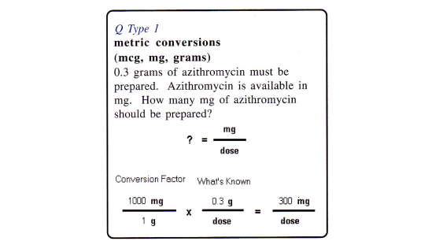
Ratio & Proportion Solution 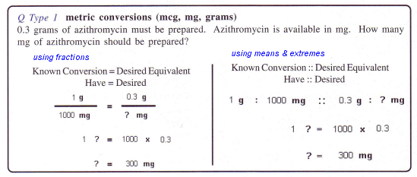

Dimensional Analysis Solution 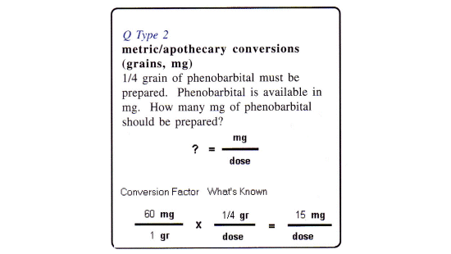
Ratio & Proportion Solution 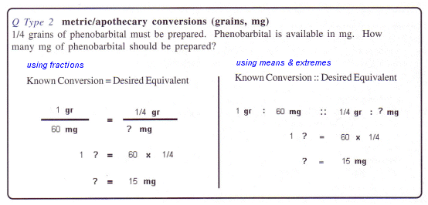
Dimensional Analysis Solution 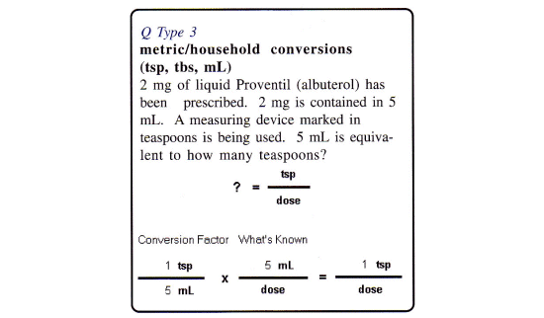
Ratio & Proportion Solution 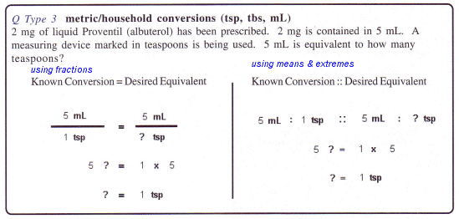
Dimensional Analysis Solution 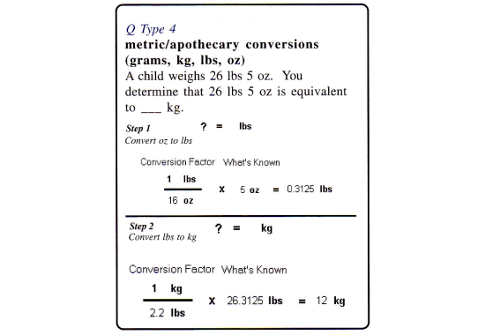
Ratio & Proportion Solution 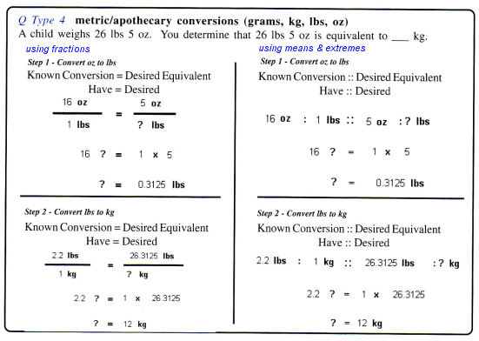
Dimensional Analysis Solution 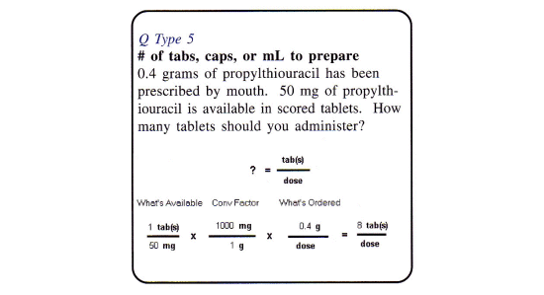
Ratio & Proportion Solution 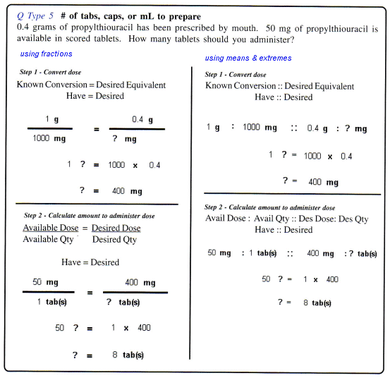
Dimensional Analysis Solution 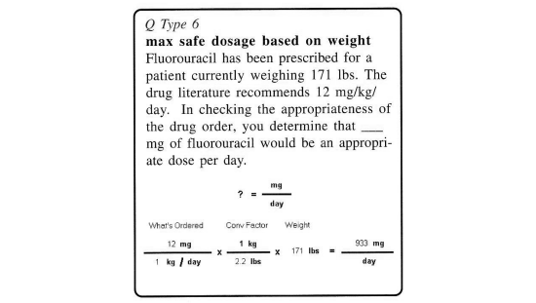
Ratio & Proportion Solution 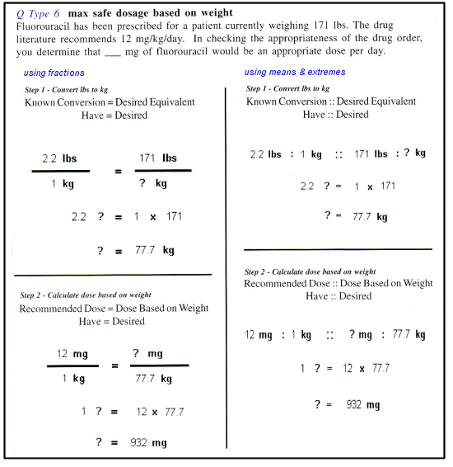 xxx 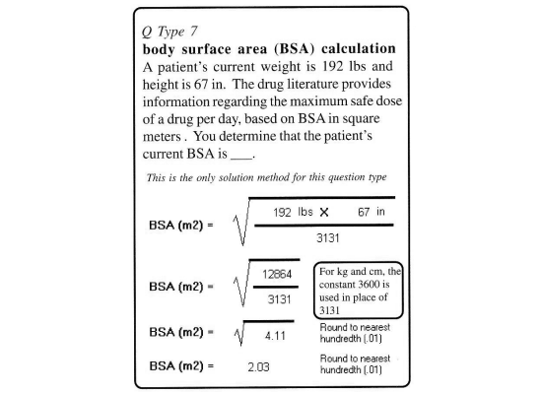xxx
Dimensional Analysis Solution 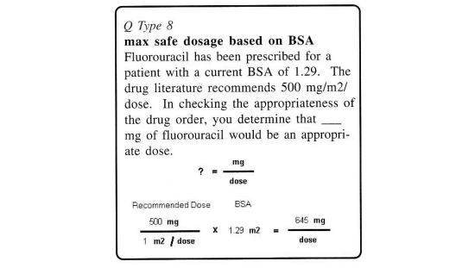
Ratio & Proportion Solution 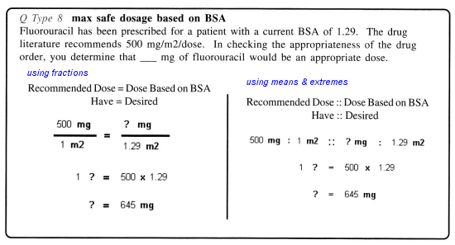 xxx 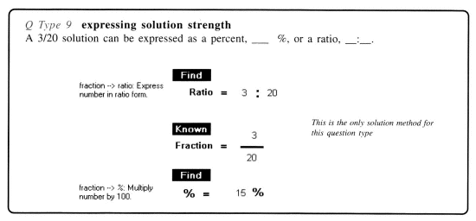xxx

Dimensional Analysis Solution 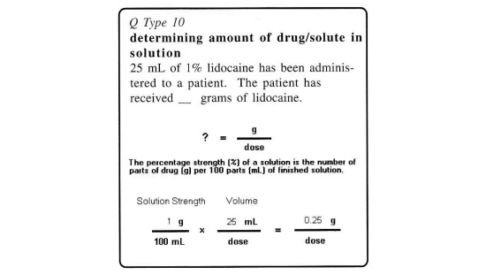
Ratio & Proportion Solution 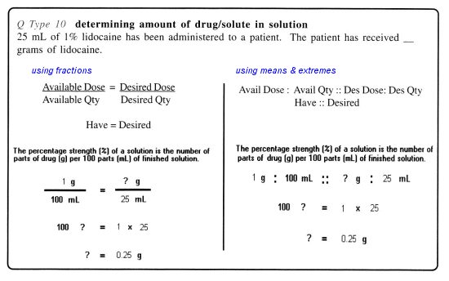
Dimensional Analysis Solution 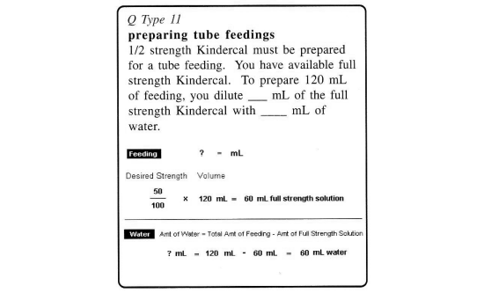
Ratio & Proportion Solution 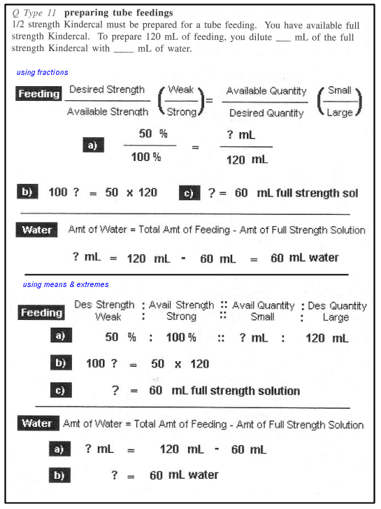
Dimensional Analysis Solution 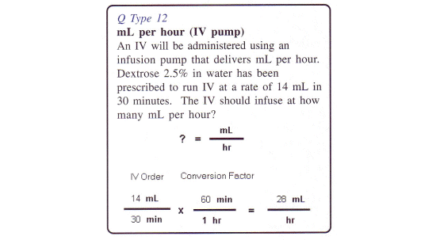Alternative Solution 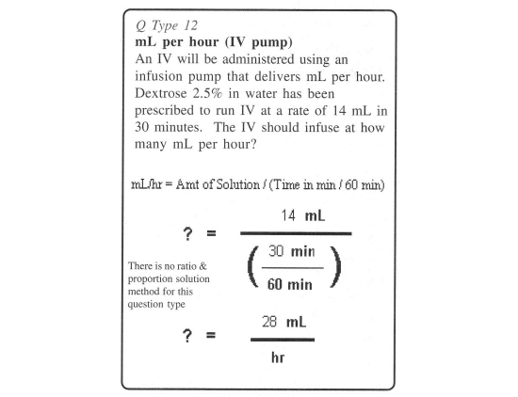
Dimensional Analysis Solution 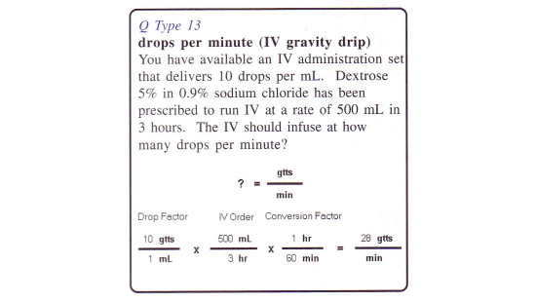Alternative Solution 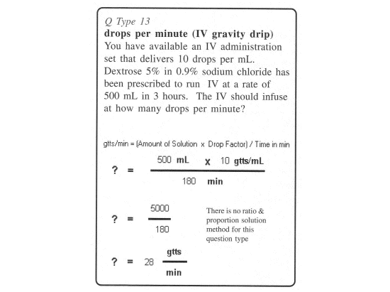
Dimensional Analysis Solution 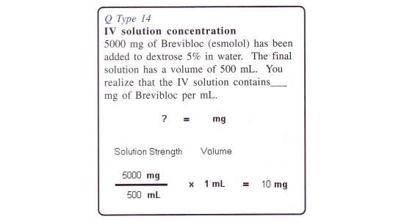
Ratio & Proportion Solution 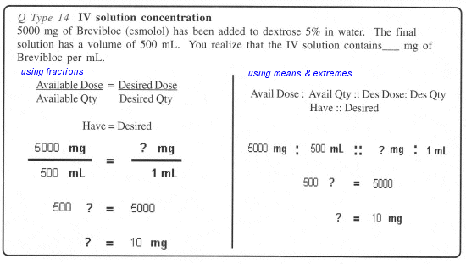
Dimensional Analysis Solution 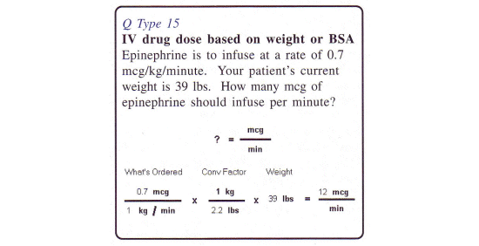
Ratio & Proportion Solution 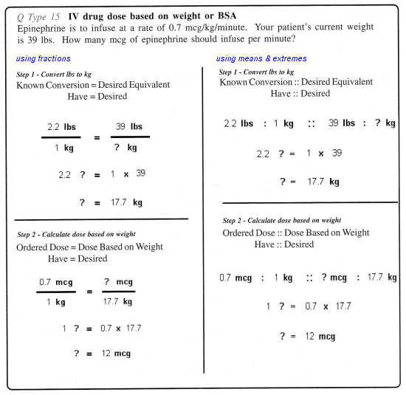
Dimensional Analysis Solution 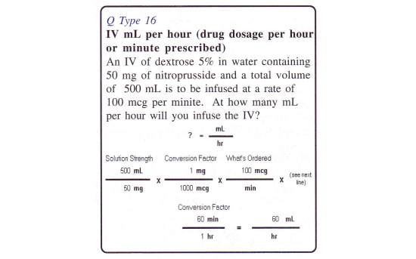
Ratio & Proportion Solution 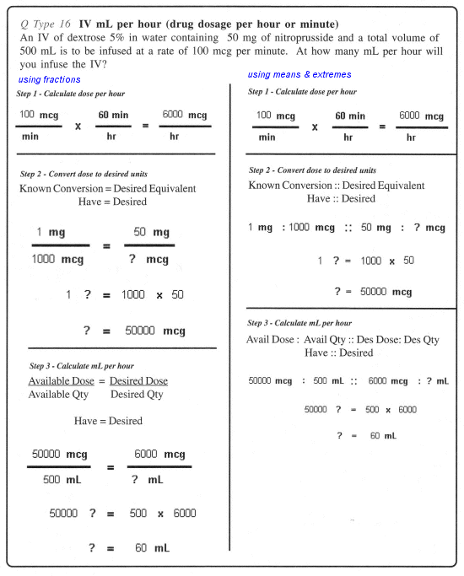
Dimensional Analysis Solution 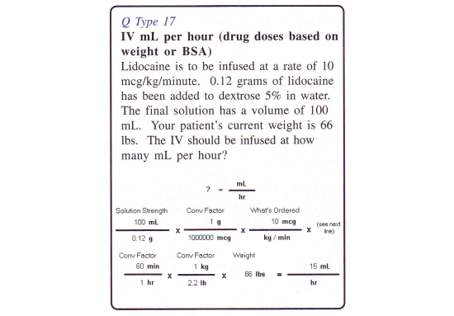
Ratio & Proportion Solution 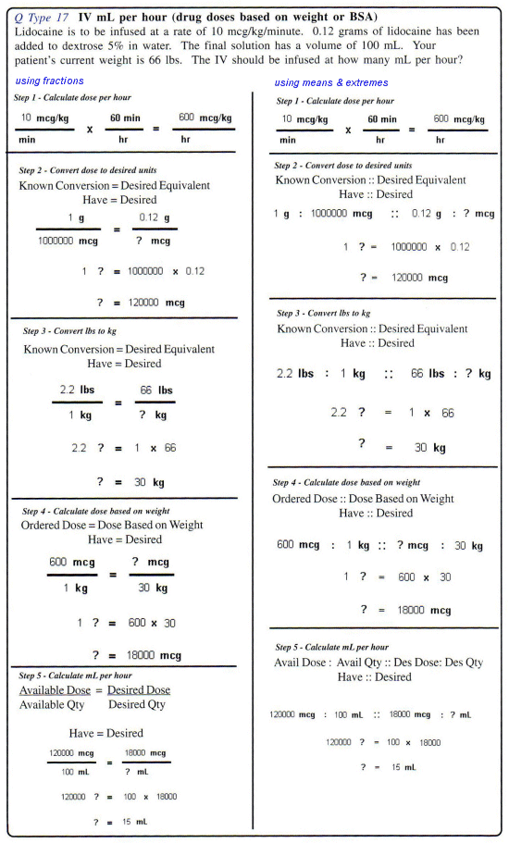
Dimensional Analysis Solution 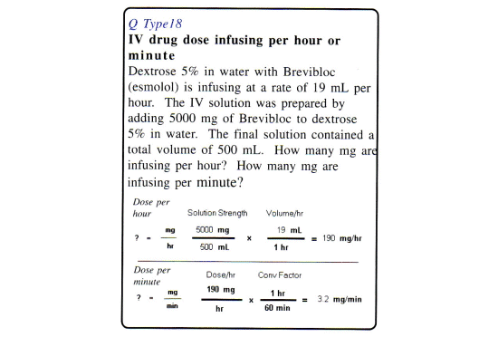
Ratio & Proportion Solution 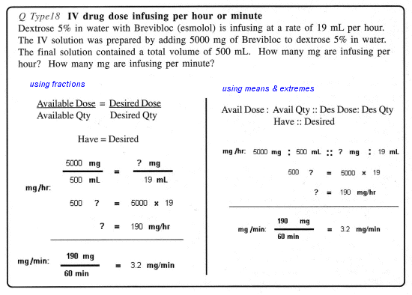
Dimensional Analysis Solution 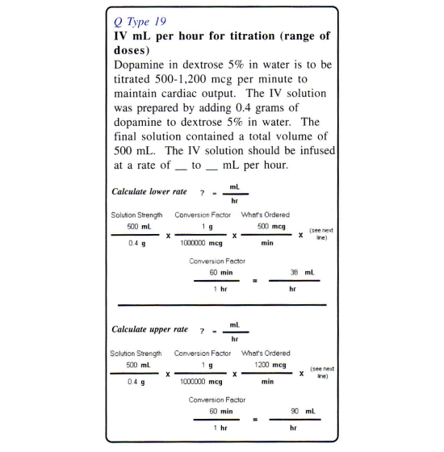
Ratio & Proportion Solution 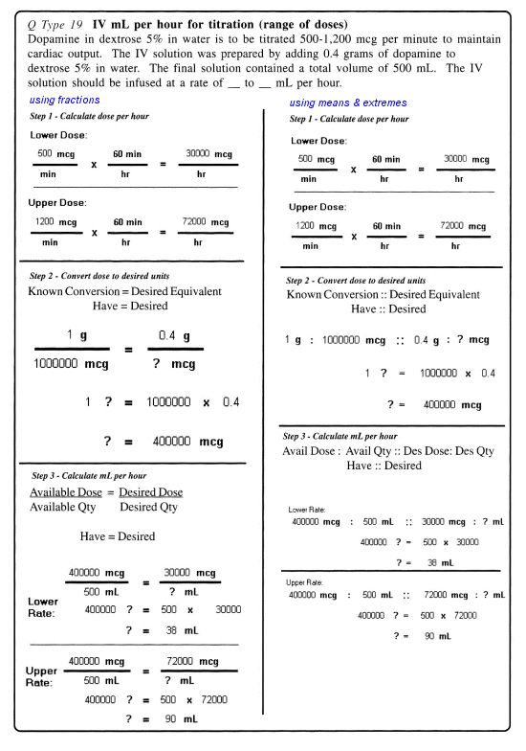
Dimensional Analysis Solution 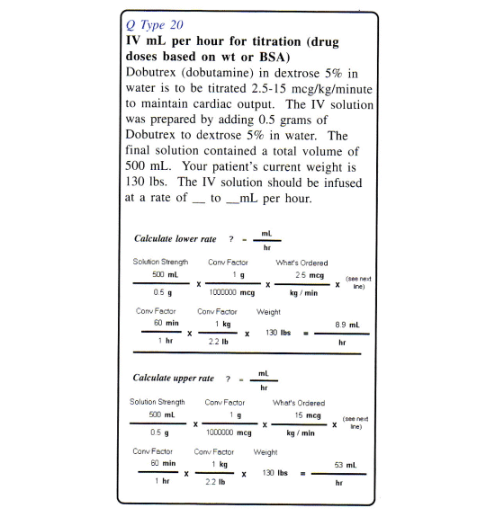

Ratio & Proportion Solution
Continued on next page

